

REPUBLIC OF CAMEROON
PEACE-WORK-FATHERLAND
*****************

AFRICAN INSTITUTE OF COMPUTER SCIENCES
BP: 13 719 Yaoundé (Cameroun)
Tel: (237) 22 72 99 57 / (237) 22 72 99 58
Email: Contact@iaicameroon.com
REPUBLIQUE DU CAMEROUN
PAIX -TRAVAIL-PATRIE
*****************

One Love, One Mind, One Legacy! LinkedIn: Shaderl Tel: (237) 678 358 509 / (237) 692 199 722 Site Web: www.shardel.com

INTERNSHIP REPORT
DESIGN AND IMPLEMENTATION OF A MULTI-PLATFORM FOR ATTENDANCE VERIFICATION

Internship carried out from 1st July to 30th September 2026. In view of a Higher Technician’s Diploma (HTD) in Computer Sciences.
option Software Engineering.
Written by:
MOMO NJIOWO CLIFF
LEVEL II student at AICS Cameroon

Professional Supervisor:
Mr. ASANE DERICK
Consultant at Shaderl
Academic Supervisor:
Mme NZALI
Lecturer at AICS Cameroon

Academic Year
2025-2026

DEDICATION

TO MY FAMILY

ACKNOWLEDGEMENTSTO MY FAMILY

ACKNOWLEDGEMENTS

SUMMARYACKNOWLEDGEMENTSTO MY FAMILY

ACKNOWLEDGEMENTSTO MY FAMILY

ACKNOWLEDGEMENTS

Drafting this document would have not been possible without the contribution of some people who took upon themselves to see this work being accomplished. Our gratitude goes to the following people:
- The Resident Representative of AICS Cameroon, Mr. ARMAND CLAUDE ABANDA, for his support, words of encouragement and the different advices on how to approach situations.
- The chief executive officer of Shaderl, Mr. ASANE DERICK, which is also my professional supervisor for trusting us by allowing us to serve as interns in their prestigious enterprise.
- Our academic supervisor, Mme Nzali, our academic supervisor, for a great follow up and advices during the realization of this document.
- To all my teachers of AICS CAMEROON for the knowledge they impacted me with for me to be where I am today.
- To my parents, Mr. RODRIGUE SADOM, Mrs MABELLE, Mrs MADELEINE for their unconditional love and support.
- To all the personnel of SHADERL for their encouragement and advices during the internship period.
- To all my friends and classmates of the 2025-2026 batch,
- To all those people near or far not cited above who contributed to the realization of this work or project

SUMMARY

DEDICATION i
ACKNOWLEDGEMENTS i
ACKNOWLEDGEMENTS ii
SUMMARY iii
LIST OF FIGURES v
LIST OF TABLES vi
GLOSSARY vii
ABSTRACT viii
RESUME ix
GENERAL INTRODUCTION 1
PART ONE: INSERTION PHASE 2
PART TWO: TECHNICAL PHASE 14
PHASE 1: EXISTING SYSTEM 15
PHASE 2: SPECIFICATION BOOK 23
PHASE 3: THE ANALYSIS PHASE 35
PHASE 4: CONCEPTION PHASE 69
PHASE 5: REALIZATION 86
PHASE 6: FUNCTIONALITY TESTING 98
PHASE 7 USER GUIDE 103
GENERAL CONCLUSION 108
ANNEXES x
BIBLIOGRAPHY xi
WEBOGRAPHY xii
TABLE OF CONTENT xiii

LIST OF FIGURES

Figure 1 Shaderl functional branch 9
Figure 2 Shaderl Geographical location plan 11
Figure 3 Gantt project 30
Figure 4 UML 2.5 diagrams overview 40
Figure 5 2TUP diagram 42
Figure 6 Use case formalism 44
Figure 7 Campusly generale use case 49
Figure 8 Specific Use case of Manage Institution 49
Figure 9 Manage Post 50
Figure 10 Manage School Manager Account 51
Figure 11 Formalism of communication diagram 53
Figure 12 Communication diagram of Authenticate 55
Figure 13 communication diagram of add post 55
Figure 14 communication diagram of start attendance session 56
Figure 15 sequence diagram formalism 57
Figure 16 Sequence diagram of Authenticate 59
Figure 17 sequence diagram of add post 60
Figure 18 sequence diagram of start attendance 61
Figure 19 Activity diagram formalism 62
Figure 20 activity diagram of authenticate 65
Figure 21 activity diagram of add post 66
Figure 22 activity diagram of start attendance 67
Figure 23 3-tier Architecture 73
Figure 24 Logical Architecture 74
Figure 25 Class Diagram formalism 75
Figure 26 Campusly Class Diagram 77
Figure 27 Formalism of state machine diagram 78
Figure 28 state machine of institution 80
Figure 29 state machine of attendance 81
Figure 30 Formalism of package diagram 82
Figure 31 Package diagram 84
Figure 32 Formalism Deployment diagram 89
Figure 33 Deployment Diagram 91
Figure 34 Formalism of Component diagram 92
Figure 35 Component Diagram 94

LIST OF TABLES

Table 1Shaderl Product 7
Table 2 Project TimeLine 29
Table 3 Software cost 30
Table 4 Hardware Costs 31
Table 5 uman Resources Costs 31
Table 6 Total Cost 32
Table 7 Project Participants 33
Table 8 Difference between Merise and UML 40
Table 9 Components of use case diagram 44
Table 10 Communication diagram component 54
Table 11 Component of sequence diagram 57
Table 12 Components of the Activity Diagram 63
Table 13 Components of activity diagram 64
Table 14 Components of a class diagram 75
Table 15 components of state machine 78
Table 16 Components of a package diagram 82
Table 17 Component of the deployment diagram 90
Table 18 Components of component diagram 92
Table 19 Technical choices 95

GLOSSARY

- 2TUP Two Track Unified Process;
- AICS: African Institute of Computer Sciences;
- DBMS: Database Management System;
- IDE: Integrated Development Kit;
- JSON: JavaScript Object Notation;
- LLM : Larger Language Model
- MERISE : Méthode d'Etude et de Réalisation Informatique pour des Systèmes d’Entreprise ;
- MVC: Model View Controller;
- MS : Microsoft
- OMT: Object Modelling Technic;
- OOSE: Object Oriented Software Engineering;
- UI : User Interface
- UML: Unified Modelling Language

ABSTRACT

The administration of academic engagement in higher education institutions and training centers in Cameroon is severely hindered by manual, paper-based attendance verification methods. Traditional roll-call processes are slow, inefficient, easily abandoned at scale, and highly vulnerable to attendance fraud such as proxy check-ins. To address these challenges, this project presents the "DESIGN AND IMPLEMENTATION OF A MULTI-PLATFORM FOR ATTENDANCE VERIFICATION".
The proposed solution, named Campusly, is a multi-tenant Software-as-a-Service (SaaS) platform built to modernize academic attendance management, guardian engagement, and institutional communication while enforcing strict tenant data isolation. The attendance verification mechanism leverages teacher-initiated Bluetooth Low Energy (BLE) proximity handshakes combined with short-lived rotating session tokens to prevent remote or photo-based check-in fraud. Furthermore, the system incorporates software-generated device-ID collision detection as a human-in-the-loop decision support tool for teachers, alongside a tiered session authority model (Teacher, Substitute, and Class Prefect fallback) to ensure continuity during instructor absence.
Developed using a cross-platform technology stack comprising React Native (mobile client), React/Next.js (administrative dashboard), Node.js with NestJS (backend REST API), and PostgreSQL. Campusly provides automated notification policies, attendance-linked academic mark deductions, and unified content publishing. This multi-platform architecture significantly reduces administrative overhead, eliminates proxy attendance, and secures permanent institutional digital records.
Keywords:
- Attendance Verification,
- Multi-Tenant SaaS,
- Bluetooth Low Energy (BLE)
- , Capability-Based Access Control,

RESUME

L'administration et la gestion de l'assiduité académique dans les établissements d'enseignement supérieur et les centres de formation au Cameroun sont fortement entravées par des méthodes manuelles sur papier. Les processus traditionnels d'appel sont lents, inefficaces, difficiles à maintenir à grande échelle et vulnérables à la fraude à la présence. Pour répondre à ces défis, ce projet intitule « CONCEPTION ET MISE EN ŒUVRE D'UNE PLATEFORME MULTIPLATEFORME DE VÉRIFICATION DE LA PRÉSENCE ».
La solution proposée, nommée Campusly, est une plateforme SaaS (Software-as-a-Service) multi-locataire conçue pour moderniser la gestion de la présence académique, l'engagement des tuteurs et la communication institutionnelle, tout en garantissant un isolement strict des données entre établissements. Le mécanisme de vérification repose sur une détection de proximité via Bluetooth Low Energy (BLE) initiated par l'enseignant, combinée à des jetons de session rotatifs à courte durée de vie pour éliminer les fraudes à distance. De plus, le système intègre la détection de collision d'identifiants d'appareils comme outil d'aide à la décision pour les enseignants, ainsi qu'une hiérarchie d'autorité de session (Enseignant, Suppléant, Chef de classe) garantissant la continuité du suivi en cas d'absence du professeur.
Développée avec une pile technologique moderne incluant React Native (application mobile), React/Next.js (tableau de bord administratif), Node.js / NestJS (API backend) et PostgreSQL, Campusly automatise les notifications aux tuteurs, le calcul des sanctions liées à l'absence et la diffusion de communications officielles. Cette architecture multiplateforme réduit considérablement la charge administrative, élimine les fraudes de présence et sécurise l'historique numérique des institutions.
Mots-clés :
- Vérification de la Présence,
- SaaS Multi-Locataire,
- Bluetooth Low Energy (BLE),
- Contrôle d'Accès Basé sur les Capacités

GENERAL INTRODUCTION

In today’s rapidly evolving digital landscape, higher education institutions and vocational training centres are increasingly adopting technology to streamline administrative operations and elevate the quality of campus engagement. However, one critical administrative domain continues to rely heavily on outdated, paper-based workflows: student attendance verification.
In many educational institutions across Cameroon and the broader region, recording student attendance is performed manually through paper roll calls or physical sign-in sheets.
To solve these core systemic inefficiencies, this project undertaken during a professional software engineering internship at Shaderl focuses on the "DESIGN AND IMPLEMENTATION OF A MULTI-PLATFORM FOR ATTENDANCE VERIFICATION". The resulting application, benchmarked under the product specification Campusly, establishes a centralized, trusted, multi-tenant digital ecosystem for higher education institutions and secondary schools.
This internship report, conducted at Shaderl, documents the development process of this innovative solution. It is structured into 2 main parts:
Insertion Phase: Here we shall talk about our host company, their services, mission, as well as our first two weeks at our host company
Technical Phase.
- The technical phase consists of:
- Existing System,
- Specification book
- Analysis book
- Design Phase
- Deployment Phase
- Test of Functionalities
- user guide

PART ONE: INSERTION PHASE

Preamble
The insertion phase document outlines the internship setting, the organizational framework, the circumstances surrounding the interns' reception, and the project to be undertaken during the internship.
Content

INTRODUCTION
- WELCOME AND INSERTION
- GENERAL PRESENTATION OF THE COMPANY
- ORGANIZATION OF THE COMPANY
- GEOGRAPHICAL LOCATION OF SHADERL
- BRIEF PRESENTATION OF PROJECT THEME
CONCLUSION

INTRODUCTION
The insertion phase in a company is a period during which we discover our working
environment, the staff of the company and other interns. Here, we will begin by discussing our first two weeks in the company, how we were welcomed and how we began adapting to our internship environment, we will proceed by exploring the history of the company, discovering its missions, learning what its major activities are, and witnessing some of its key realizations. We will also get to understand how the company is structured administratively and functionally so that it operates effectively and accomplishes its goals. Furthermore, we will look at the hardware equipment used by the company, and the software resources used in its daily operations. We will then introduce our chosen theme for the internship period, briefly elaborate on It.

I-WELCOME AND INSERTION
We arrived at SHADERL on Wednesday 01st July 2026, at 08:30 am. we were received by the shaderl team who introduced us to our workspace, gave us an official welcome to the enterprise, its activities and its different rules and regulations. Also, we discussed on the enterprise’s preferred languages and frameworks, our professional supervisor encouraged us through his past working experiences in different enterprises.
The first two week we started with our internship report by configuring our MS WORD processor, reviewing key concepts like page numbering, styles, section breaks, page breaks etc. There was a talk on project ideas, we were advised to propose project ideas and we were assigned the tasks to carry out research on these ideas. The objective was that the enterprise did not want to impose some themes on us. For those who could not find a theme, the enterprise could propose an idea for them to think about.

II-GENERAL REPRESENTATION OF SHADERL

A-Background:
Shaderl is a dynamic, non-governmental tech startup founded in 2023 by Mr. Asane Derick with a bold vision: to bridge the gap between traditional industries and the rapidly evolving digital economy. Recognizing the urgent need for digital transformation, Shaderl is committed to providing cutting-edge IT solutions while empowering the next generation of innovators.

B- Mission
At Shaderl, we harness the power of AI and cutting-edge technology to democratize digital transformation. Our mission is to empower individuals and businesses with intelligent tools, accessible education, and personalized mentorship bridging the gap between today’s potential and tomorrow’s opportunities. We believe AI should augment human potential, not replace it. By making AI-driven solutions practical and ethical, we equip the next generation to lead, innovate, and thrive in an era where human creativity meets machine intelligence.

C-Vision
At Shaderl, we envision a world where technology unites humanity, where innovation is driven by collective purpose, not just profit. By putting “PeopleFirst”, we strive to build a future where:
-One Love→ Technology fosters inclusion, empathy, and global collaboration, breaking down barriers.
-One Mind→ AI and digital tools amplify human potential, creating shared knowledge and opportunity.
-One Legacy→ Every individual we empower leaves a lasting impact, shaping a smarter, kinder, and more connected world.
We don’t just adapt to the digital age; we redefine it with humanity at the core.

D- ACTIVITIES
The activities of SHADERL range from computer sciences, engineering, and training. We can outline the following:
Conception realization, and hosting of websites.
Software development and maintenance.
Training in Software related fields.
Conception and realization of multimedia.
AI driven solutions
IT consulting and innovation.

E- PRODUCTS
Table 1Shaderl Product
NO | NAME | DESCRIPTION | LOGO
1 | ShaderlStock | ShaderlStock is an application, which helps small, medium and large businesses to manage their inventory, with the help of a QR code and AI assistance for more complex queries. | 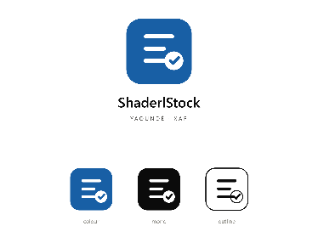
2 | ShaderlAlgorithm | It is an application, which helps individuals in the society to learn how to write algorithms and programing, despite their educational background. With the help of artificial intelligence. | 

III-ORGANISATION OF SHADERL
Shaderl is administratively organized as follows

Administrative Organization
a- Executive Leadership
This department is responsible for:
✓ Setting the company's vision, mission, and strategic direction
✓ Making high-level decisions about investments, partnerships, and growth
✓ Representing Shaderl in key meetings with investors and government agencies
✓ Ensuring all departments align with the company's core values and objectives
✓ Overseeing the overall performance and sustainability of the organization

b. Software Engineering Department
This department is responsible for:
✓ Designing, developing, and maintaining all of Shaderl's software products
✓ Implementing AI and machine learning solutions for company offerings
✓ Ensuring software security, scalability, and optimal performance
✓ Collaborating with other departments to understand technical requirements
✓ Staying updated with emerging technologies and industry best practices
c. Human Resource Department
This department is responsible for:
✓ Recruiting and onboarding top talent that aligns with Shaderl's values
✓ Managing employee relations, welfare, and performance evaluations
✓ Developing training programs to enhance staff skills and capabilities
✓ Maintaining company culture and ensuring a positive work environment
✓ Handling compensation, benefits, and conflict resolution
d Communication Department
This department is responsible for:
✓ Managing Shaderl's public image and brand reputation
✓ Developing and executing marketing and PR strategies
✓ Handling all internal and external communications
✓ Managing social media platforms and digital content
✓ Organizing corporate events and press engagements

e Department of Financial Affairs
This department is responsible for:
✓ Managing all financial operations and accounting
✓ Preparing budgets and financial forecasts
✓ Handling payroll, taxes, and financial reporting
✓ Ensuring compliance with financial regulations
✓ Managing investments and financial partnerships

Functional Organization
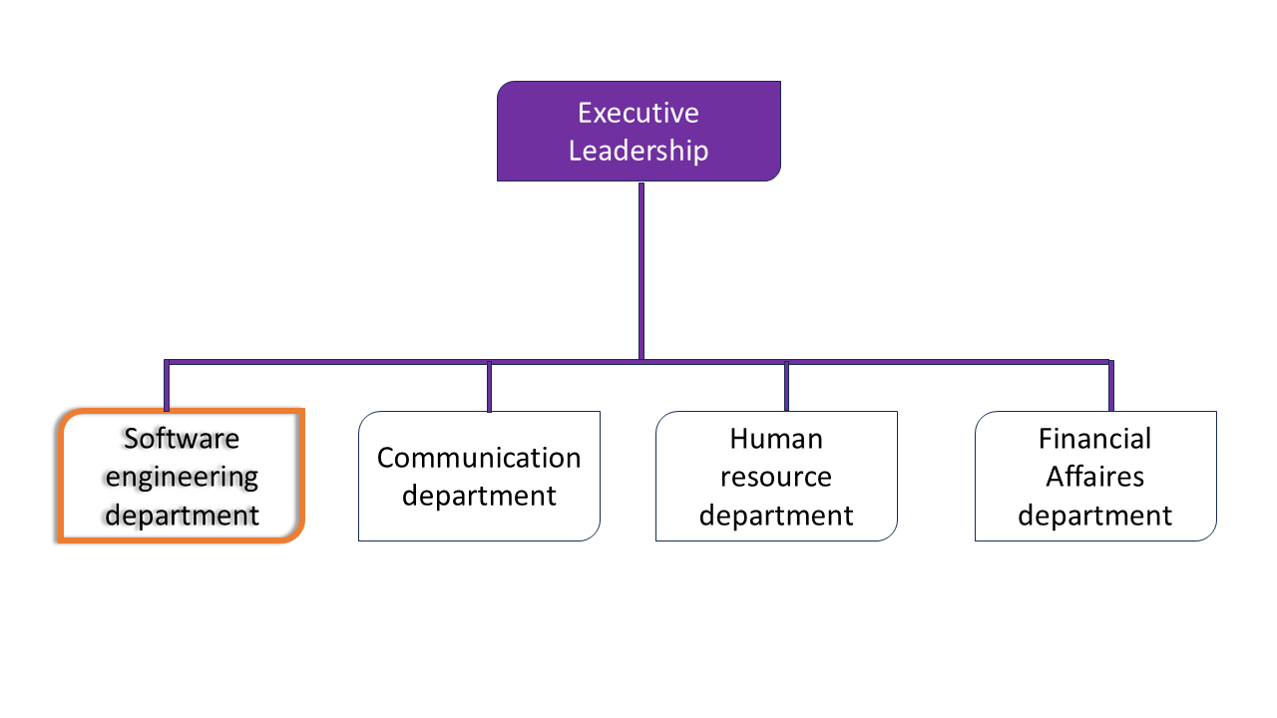
The functional branch of Shaderl is organized as follows:
Figure 1 Shaderl functional branch

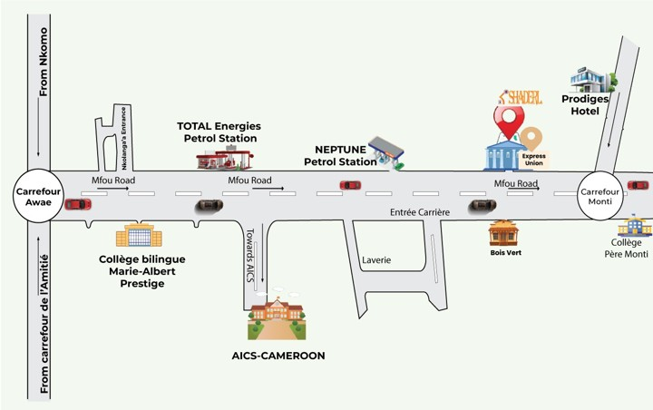
IV- GEOGRAPHICAL LOCATION OF SHADERL
Figure 2 Shaderl Geographical location plan

V BRIEF PRESENTATION OF THE PROJECT THEME
The project, titled "DESIGN AND IMPLEMENTATION OF A MULTI-PLATFORM FOR ATTENDANCE VERIFICATION," was conducted during a professional internship at Shaderl to address the operational vulnerabilities of traditional, paper-based student attendance tracking in Cameroonian higher education institutions and training centers. Manual roll calls and paper sign-in sheets consume up to ten minutes of valuable lecture time per session, cause significant administrative delays, and remain highly susceptible to attendance fraud, such as proxy check-ins. Simple digital alternatives like static QR codes or shareable links similarly fail because they can be forwarded outside the classroom. To overcome these challenges, this project delivers Campusly, a multi-tenant Software-as-a-Service (SaaS) multi-platform ecosystem that modernizes attendance tracking, institutional communication, and guardian engagement while maintaining strict tenant data isolation. The core attendance verification mechanism relies on teacher-initiated Bluetooth Low Energy (BLE) dynamic handshakes paired with short-lived rotating session tokens to ensure physical classroom presence and eliminate remote check-ins. Coupled with software-driven device ID collision detection to flag shared physical devices, a flexible session delegation model (Teacher, Substitute, Class Prefect), and automated academic penalty and notification engines, Campusly provides a complete, cross-platform solution consisting of a React Native mobile application for classroom interactions, a React/Next.js web portal for administration, and a unified NestJS and PostgreSQL back-end.

CONCLUSION
Our insertion phase at SHADERL lasted for two weeks. We discovered the environment where we found ourselves in. This environment put it in place all the necessary requirements for hard work and collaboration. We learned about t company’s missions and its different activities. We met other interns with whom we were doing collaborative works and finally, we choose our theme DESIGN AND IMPLEMENTATION OF A MULTI-PLATFORM FOR ATTENDANCE VERIFICATIUON

PART TWO: TECHNICAL PHASE

PHASE 1: EXISTING SYSTEM
Preamble
This section of our report will cover details of the different research did for the realization of this project. The existing study, criticism of the existing system, problem statement, proposed solutions.
Content

INTRODUCTION

- THEME/PROJECT PRESENTATION
- STUDY OF THE EXISTING SYSTEM
- CRITICISM OF THE EXISTING SYSTEM
- PROBLEMATICS
- PROPOSED SOLUTION
CONCLUSION

INTRODUCTION
Engineers are society’s problem solvers working to make life easier for everyone. The existing system refers to the system put in place to carry out the work done in the field on which our theme is based. Understanding this system is a great step in solving the problems that we might identify. It’s of great importance that we take into consideration this system before proposing a suitable solution that will ameliorate or replace the current one.

PRESENTATION OF THE THEME
This internship project is centered on the theme: "Design and Implementation of a Multi-Platform for Attendance Verification." While attendance verification is the primary technical focus and origin point of this project, it was developed as one half of a broader digital campus engagement platform, whose second core objective is to provide institutions with a trusted, official channel for communicating information announcements, events, opportunities, and academic updates to their students, guardians, and staff.
These two objectives, though distinct in function, address a single underlying problem: higher education institutions lack reliable, institution-controlled digital infrastructure for two of their most routine but critical processes verifying student presence, and communicating official information. Attendance is currently tracked manually, consuming valuable instructional time and producing unreliable, easily falsified records. In parallel, institutional communication scholarships, events, academic announcements is scattered across informal channels such as WhatsApp groups and physical notice boards, with no way to verify authenticity or guarantee that it reaches its intended audience.
This project therefore proposes a mobile-based platform built around two integrated pillars:
- Automated attendance verification, using Bluetooth Low Energy (BLE) proximity detection to mark enrolled students present automatically when a teacher starts a class session, with built-in safeguards against common forms of attendance fraud.
- Trusted institutional communication, providing a single, verified publishing channel through which institutions can share official announcements, events, and opportunities directly with their community, replacing fragmented and unofficial channels.
While the technical depth of this report centers primarily on the attendance verification component reflecting the scope of the internship period the design of the system was carried out with both objectives in mind, ensuring the two pillars share a coherent underlying architecture (a unified user/permission model, a multi-tenant data structure, and a single mobile application) rather than functioning as separate, disconnected tools.

DESCRIPTION OF THE EXISTING SYSTEM
- Attendance Tracking
In most higher education institutions, attendance is recorded manually. At the start of each class session, the teacher takes a printed or handwritten class list and calls out each student's name individually, waiting for a verbal response before marking the student present or absent. Once the session ends, this paper record is retained by the teacher and, at defined intervals (typically weekly), submitted to the administrative office, where the data is manually transcribed into a central register either a physical ledger or, in some cases, a basic spreadsheet.
- b. Institutional Communication
In parallel, institutions currently rely on a mix of informal and semi-formal channels to communicate with their community. Physical notice boards are used to post announcements, but reach only students who happen to walk past them. Social media pages are used for public-facing news, but posts quickly disappear beneath unrelated content and are not always seen by the intended audience. WhatsApp groups, often containing hundreds of members, are used for day-to-day communication, but the sheer volume of unrelated messages means important announcements are easily missed or ignored. Critically, none of these channels offer a way to verify that a given message is truly official, nor do they preserve a searchable, permanent record of past announcements.

CRITICISMS OF THE EXISTING SYSTEM.
a. Attendance Tracking
- Time-consuming: calling names individually for a class of 80–100+ students can consume 10–15 minutes of instructional time per session, repeated across every class, every day.
- Error-prone: misheard names, students answering on behalf of absent classmates, and manual transcription errors all introduce inaccuracies into the record.
- No fraud resistance: a student can easily answer "present" on behalf of an absent classmate, with no mechanism to detect or prevent this.
- Fragile record-keeping: paper attendance sheets can be lost, damaged, or misplaced during transfer between teacher and administration, resulting in permanent, unrecoverable gaps in the record.
- Delayed visibility: because records are transcribed only periodically, neither the administration nor guardians have real-time visibility into a student's attendance pattern.
- No audit trail: there is no way to verify after the fact who recorded a given attendance session, when it was recorded, or whether it was later altered.
b. Institutional Communication
- Fragmentation: official information is scattered across notice boards, social media, and messaging groups, with no single authoritative source.
- No verification: recipients have no reliable way to distinguish an official announcement from a rumour or an outdated post.
- Poor reach: important information such as scholarship deadlines frequently fails to reach the students it is most relevant to, simply because they were not looking at the right channel at the right time.
- No permanence: announcements posted on social media or shared in a chat group quickly become buried and effectively unsearchable, meaning institutional history and past opportunities are lost over time.
- No audience targeting: informal channels cannot easily distinguish between information meant for the general public, for enrolled students only, or for staff everything is broadcast the same way to whoever happens to be present

LIMITATIONS OF THE EXISTING SYSTEM
Beyond their day-to-day weaknesses, both existing systems share a fundamental limitation: they are not designed to scale, and they depend entirely on human diligence, memory, and informal habits rather than structured, verifiable processes. The manual attendance process depends on the teacher's accuracy and the safekeeping of a physical sheet at every step. Informal communication depends on students actively monitoring multiple unofficial channels and institutions manually re-posting the same information in several places, with no guarantee of consistency or reach. As student populations grow, both problems compound rather than resolve themselves, and neither system offers institutions any way to monitor, verify, or improve the process over time.

PROBLEMATIC
Through these various observations we ask ourselves HOW CAN HIGHER EDUCATION INSTITUTIONS RELIABLY VERIFY STUDENT ATTENDANCE AND COMMUNICATE OFFICIAL INFORMATION TO THEIR COMMUNITY, WITHOUT DEPENDING ON MANUAL, FRAGMENTED, AND UNVERIFIABLE PROCESSES? We will try to offer solutions through our application.

PROPOSED SOLUTION
To address this dual problem, this project proposes a single mobile platform built around two integrated components.
- For attendance, a teacher initiates a time-bound session from their device at the start of class. Enrolled students' devices detect this session via Bluetooth Low Energy (BLE) proximity and are automatically marked present, without any manual roll-call. To resist common forms of fraud such as one student checking in on behalf of an absent classmate the system incorporates a device-identity collision check: if the same physical device is used to check in more than one student account within the same session, the discrepancy is flagged to the teacher for manual review rather than resolved automatically, preserving human judgment for edge cases while eliminating the routine burden of manual attendance-taking.
- For institutional communication, the platform provides each institution with a single, verified publishing channel. Authorized staff publish official announcements, events, and opportunities directly to the platform, where they are visible to the correct audience (public, student-only, or staff-only, depending on content), permanently archived, and searchable replacing the current reliance on scattered, unofficial channels with one trusted institutional source of truth.

CONCLUSION
This section has presented the two existing systems, manual attendance tracking and informal institutional communication examined their key weaknesses and limitations, and defined the central problem this project sets out to solve. Having established this foundation, the next section the Specification Book will formally define the project's objectives, functional and non-functional requirements, planning, and constraints.

PHASE 2: SPECIFICATION BOOK

Preamble
The Specification book is a document which is been established by the customer needing a particular product and the producer (engineer) who is to create the product, which is to be respected to its fullness during the realization of the product. From this, we obtain the major importance of the specification book.
Content

INTRODUCTION
- CONTEXT AND JUSTIFICATION
- OBJECTIVES OF THE PROJECT
- EXPRESSION OF NEEDS
- PROJECT PLANNING
- ESTIMATED COST OF THE PROJECT
- PROJECT CONSTRAINTS
- DELIVERABLES
CONCLLUSION

INTRODUCTION
The specification book of our report helps us provide details about our theme to improve our understanding of it and increase the likelihood of its success. To delimit the scope of our project, we will specify the context of our theme. From the context, we will list the problems we have decided to address throughout the project. After presenting our solution, we will talk about the objective we have set for the project. Also, we will explore the needs to which our system will respond, both at the functional and non-functional level. We will then look at the estimated financial requirements for our project and establish a plan we will follow to complete our project on time. From here, we will discuss what is expected of us by the end of the project under the project deliverables.

CONTEXT AND JUSTIFICATION
a. Context
Manual attendance tracking and informal institutional communication remain the dominant practices in higher education institutions. The former consumes significant instructional time and produces records that are difficult to verify or trust; the latter leaves institutions without a reliable, official channel to reach their own community. As institutions grow in size and complexity, the limitations of both approaches become increasingly costly in lost teaching time, in unreliable data, and in missed opportunities for students who never receive information meant for them.

b. Justification
Addressing both problems within a single platform is justified by the fact that they share a common root cause the absence of institution-controlled digital infrastructure and a common set of stakeholders: students, guardians, teachers, and administrators. A digital, proximity-based attendance system reduces the time cost of attendance-taking to near zero and produces a permanent, auditable record. A verified communication channel ensures official information reaches its intended audience reliably and is preserved for future reference. Building both on a single, unified platform rather than as separate, disconnected tools — allows the two to share a common user and permission model, reducing both development effort and the complexity institutions face when adopting the system.

OBJECTIVES OF THE PROJECT

GENERAL OBJECTIVE
To design and implement a mobile-based multi-platform system that automates student attendance verification and provides institutions with a trusted channel for official communication.
.

SPECIFIC OBJECTIVES
- To design a Bluetooth Low Energy (BLE)-based mechanism for detecting student presence during a class session.
- To implement a teacher-controlled session model that scopes attendance-taking to a specific class, time window, and enrolled student list.
- To design and implement a device-identity collision detection mechanism to flag potential attendance fraud for teacher review.
- To provide teachers with a live view of attendance during an active session, including the ability to manually correct records.
- To provide students and guardians with real-time access to attendance records.
- To design a content publishing system allowing institutions to share official announcements, events, and opportunities with the correct target audience.
- To ensure published institutional content is permanently archived and searchable.
- To ensure the system functions reliably across both Android and iOS devices.

EXPRESSION OF NEEDS

Functional Needs
- Attendance:
- The system shall allow a teacher to start and stop a time-bound attendance session for a specific class.
- The system shall detect enrolled students' devices via BLE when they are in proximity to the teacher's active session.
- The system shall automatically mark a detected, enrolled student as present.
- The system shall prevent a device from being used to check in more than one student account within the same session without flagging it for review.
- The system shall allow the teacher to view a live list of students marked present during an active session and manually correct entries.
- The system shall allow students to view their own attendance history.
- The system shall notify guardians of a student's absence.
- Communication:
- The system shall allow authorized institutional staff to publish announcements, events, and opportunities.
- The system shall allow content to be scoped to a specific audience (public, student-only, or staff-only).
- The system shall permanently archive published content and make it searchable by category, tag, and date.
- The system shall allow users to react to and, where permitted, comment on published content.

Non-Functional Needs
- Performance: attendance check-in should complete within a few seconds of a student's device coming into range of an active session.
- Reliability: the system must function consistently across common Android and iOS device models.
- Security: device identifiers used for fraud detection must be non-biometric and privacy-respecting.
- Usability: the interface must be simple enough for a teacher to start a session in under a few taps, with no training required.
- Availability: the system should gracefully handle temporary network interruptions without losing recorded attendance data.
- Data isolation: content and data belonging to one institution must never be accessible to another institution using the same platform.

PROJECT PLANNING

Chronogram of activities
We began our internship on the 1st of July, till the 30th of September 2026, a total of 3 months. To this, it was an obligation for us to manage our time properly so as to finish on time. This section presents how the work phases were scheduled throughout my internship period.

Table 2 Project TimeLine
Phases | Objective | Output | Duration Period
Requirement Analysis | Identify user needs and analyze existing system | Requirement specification document, survey results | 06/07/2026 to 19/07/2026
System Design | Design system architecture and create UML diagrams | System architecture, UML diagrams (e.g., use case, class) | 20/07/2026 to 01/08/2026
Development | Build frontend, backend, and integrate mock payment APIs | Functional prototype with core features | 02/08/2026 to 29/08/2026
Testing | Validate functionality through unit and user acceptance tests | Test reports, bug fixes, validated prototype | 30/08/2026 to 09/09/2026
Deployment | Deploy prototype, create user guide | Deployed system, user guide document | 10/08/2026 to 12/09/2026
Documentation | Finalize internship report and defense presentation | Complete report, presentation slides | 14/09/2026 to 21/09/202

Gantt Project planning
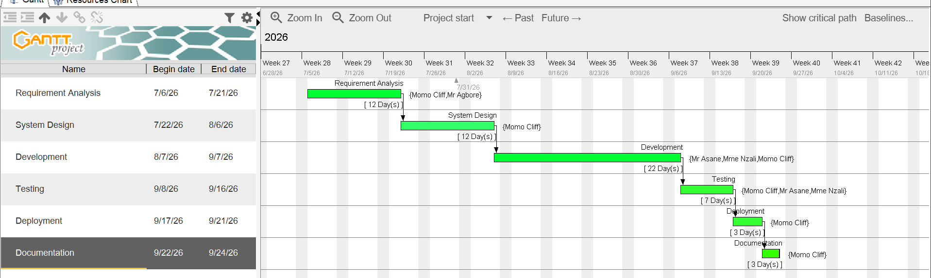
Figure 3 Gantt project

ESTIMATED COST OF THE PROJECT

Software Resources
For the realization of this project, we will need the following software applications:
Table 3 Software cost
Resource | Designation | Usage | Quantity | Unit Cost (FCFA)
MS Word | Documentation | Report writing | 1 | Free
GitHub | Version control / hosting | hosting Source code management | 1 | Free
PostgreSQL | Database | Store attendance and user data | 1 | Free
Visual Studio Code | Code editor | Application development | 1 | Free
TOTAL |  |  |  | 0

Hardware Resources
This includes the material resources used to realize this project. The table below shows a representation of these different materials:
Table 4 Hardware Costs
Hardware Resource | Quantity | Unit Cost (FCFA) | Total (FCFA)
Laptop (development machine) | 1 | 450,000 | 450,000
Android smartphone (BLE testing) | 1 | 120,000 | 120,000
iPhone (iOS BLE testing) | 1 | 350,000 | 350,000
TOTAL |  |  | 920,000

Human resources

Table 5 uman Resources Costs
Role | Quantity | Total Price (FCFA)
Project Manager | 1 | 975,000
Analyst | 1 | 240,000
UI/UX Designer | 1 | 150,000
Programmer | 1 | 300,000
Tester | 1 | 80,000
TOTAL |  | 1,745,000

Global Estimation

Table 6 Total Cost
Category | Cost (FCFA)
Total Software | 0
Total Hardware | 920,000
Total Human Resources | ,745,000
Total | 2,665,000

LIST OF PARTICIPANTS
The table below presents the different persons who took part in the accomplishment of this project. They include:

Table 7 Project Participants
Names | Functions | Role and Tasks
Mr Asane Derick | Shaderl CEO | Professional Supervisor
Mme Nzali | Lecturer at AICS-Cameroon | Academic Supervisor
Momo CLiff | Level two Student at AICS-Cameroon | Project head, analyst, conception and coding of project, testing

PROJECT CONSTRAINTS
- Time constraint: the project must be completed within the three-month internship period
- Hardware constraint: BLE behavior varies across device manufacturers and operating systems, requiring testing across multiple device types.
- iOS background restriction constraint: iOS limits background Bluetooth scanning, requiring the app to remain in the foreground during attendance check-in.
- Data privacy constraint: the system must avoid collecting unnecessary personal data and must not use hardware-level identifiers for device tracking.
- Multi-tenancy constraint: the system must enforce strict data isolation between institutions sharing the same platform infrastructure.

DELIVERABLES
- A functional mobile application prototype implementing BLE-based attendance verification and institutional content publishing.
- Complete UML documentation (use case, class, sequence, activity diagrams).
- A user guide for teachers, students, and institutional staff.
- The complete internship report.

CONCLUSION
To conclude, the specification book has permitted us to present the general and specific objectives of the project, the project constraints, the functional and nonfunctional needs of the project, lay out the different resources of the project, and finally, the project planning. The end of this document will enable us to easily dive into drafting the analysis document, which will bring out the technical aspects of the project as a whole.

PHASE 3: THE ANALYSIS PHASE

Preamble
The analysis document that adheres to the specifications provides a comprehensive overview of the issue and the proposed solution, supported by diagrams. It outlines the selected analysis method for the project and explains the rationale behind this choice. All of these elements contribute to a clearer understanding of the information system being modeled.
Content

INTRODUCTION
- METHODOLOGY
- COMPARATIVE STUDY BETWEEN MERISE AND UML
- PRESENTATION OF THE 2TUP
- CHARACTERISTICS OF THE 2TUP
- JUSTIFICATION OF THE CHOICE OF THE ANALYSIS
- MODELING
- USE CASE DIAGRAM
- COMMUNICATION DIAGRAM
- SEQUENCE DIAGRAM
- ACTIVITY DIAGRAM
CONCLUSION

INTRODUCTION
The analysis book permits us to examine in an explicit way the existing system, it’s limitations and how we can remedy them. We will also describe in details the modeling language known as UML (Unified Modeling Language) which is coupled with Two Tract Unified Process (2TUP) to form a method and its justification why we decided to use it in preference of another. then we will dive directly into the modeling of the proposed solution consisting of diagrams that meets the requirements of the functional needs.

METHODOLOGY
Analysis is the fundamental step in the conception of software. It is the basis for the realization of every information system. An information system is an organization of resources (human, software, and hardware), data, and feedback to attain a specific objective. Several methods and languages have been put in place to facilitate the analysis and conception of information systems, which principally have UML and MERISE.

COMPARATIVE ANALYSIS BETWEEN MERISE AND UML
- MODELING WITH MERISE (2.5)
MERISE stands for “Méthode d’Etude et de Réalisation Informatique pour des Systèmes d’Entreprise”. Although it is prescriptive to some extent, MERISE permits the participation of end users and senior management as well as data processing professionals in its decision cycle. MERISE is a method for designing, developing and carrying out IT projects. The goal of this method is to achieve the design of an information system. The MERISE method is based on the separation of data and processing to be carried out in several conceptual and physical models. The essentials of the approach lie in its three cycles: the decision cycle, the life cycle and the abstraction cycle, which cover data and process elements equally. The separation of data and processing ensures longevity in model. Indeed, the arrangement of data does not have to be often overhauled, while treatments are more frequently

- MODELING WITH UML (2.5)
The unified modeling language (UML) is a general purpose, developmental modeling language in the field of software engineering that is intended to provide a standard way to visualize the design of a system. The Unified Modeling Language (UML) was standardized in January 1997 by the Object Management Group (OMG) which is an American association created in 1989 and aims to promote and standardize the object model in all its forms. In 2005, UML was also published by the international organization for standardization (ISO) as an approved ISO standard. UML since 2015 is in its version 2.5. This version consists of fourteen diagrams classified into structural and behavioral diagrams
- Structural Diagrams
Structural diagram represents the static components of a system; they emphasize on what should be in the system we are modeling. They include:
- Class diagram
- Object diagram
- Package diagram
- Composite diagram
- Deployment diagram
- Component diagram
- Profile diagram
- Behavioral diagrams
The behavioral diagrams capture the dynamic state of a system, they emphasize on what should happen in the system we are modeling, they are:
- Use case diagram
- Activity diagram
- State machine diagram
- Sequence diagram
- Communication diagram
- Interaction overview diagram
- Timing diagram

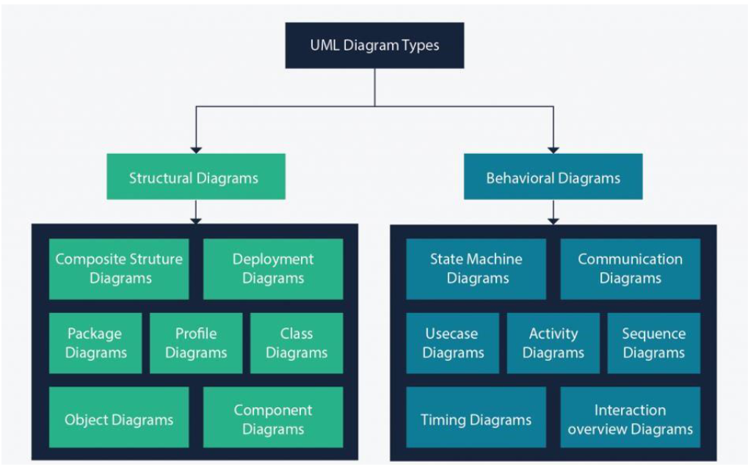
Figure 4 UML 2.5 diagrams overview

It is important to note that UML is a modeling language and not a method or procedure. Hence, to give it an approach, we need to associate UML to a Unified process (UP) in order to give our conception a methodology to follow. A unified process is a generic method for developing software. This implies it is necessary to adapt the UP to the context of the project, team domain and or the organization. We will use the Two Tracks Unified Process (2TUP) throughout our project to implement our solution.

Table 8 Difference between Merise and UML
MERISE | UML
Méthode d’Etude et de Realization Informatique pour les Systèmes d’Entreprise | Unified Modeling Language
Merise is a method of analysis. | UML is a modeling language
Merise is a systematic method of analysis and design for information systems, i.e., it uses a system approach. | UML is, however, not a method but rather an object-oriented language, uses the 2TUP approach to model a system
It is based on a procedural approach | Based on object approach
Merise proposes to consider the real system from two points of view:  • The Static view(data)  • The Dynamic view(treatments). Which means in Merise, we have a separate study of data and treatments | UML offers a different approach from that of MERISE in that it combines data and process

PRESENTATION OF THE 2TUP
2-TUP (Two Track Unified Process) is “Y “in shape and is a unified process that has as its objective to bring a solution to constraints of functional changes imposed on information systems. It proposes a development cycle that separates the functional aspects from the technical aspects. 2-TUP therefore distinguishes two main branches:
(The functional and technical branch) whose different results are being merged to realize our system.
Any unified process UP (Unified Process) process meets the following characteristics:
- It is iterative and incremental.
- Some of the advantages of the 2TUP include:
- It allows the addition of modules.
- It allows flexibility in the analysis of a project.
- It is easy to design and understand.
- It allows to have a preliminary view
- Below is the representation of 2-TUP:

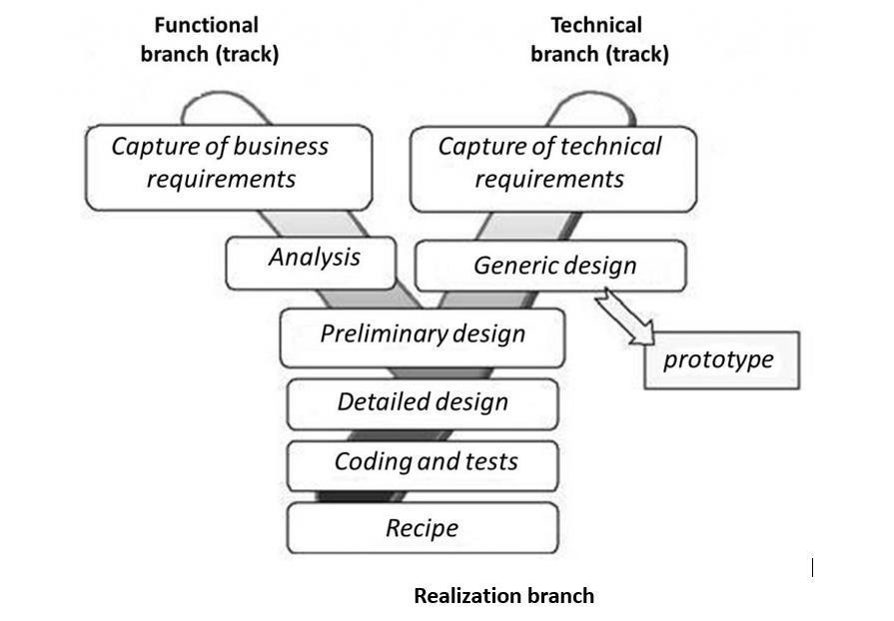
Figure 5 2TUP diagram

- The left branch (functional branch)
It captures the functional needs of a system. This ensures the production of software that meets the needs/requirements of the user. The analysis here consists of studying precisely the functional specification in order to obtain an idea of what the system is going to realize and its result does not depend on any technology

- The right branch (Technical branch)
The technical branch enumerates the technical needs and proposes a generic design validated by a prototype. The technical needs include constraints and choices related to the conception of the system, the tools and equipment as well as the integration constraint with the existing system condition. The different diagrams are shown in the tables below.

- The middle branch (Realization or implementation branch)
In this branch, we study the preliminary conception, detailed conception, and documentation of the system. The realization branch supports the following: Preliminary conception: This is the most sensitive step of 2TUP as it is the confluence of the functional and technical branch. It is completed when the deployment model, the operating model, the logical model, interphases and the software configuration model are defined. Detailed conception: This is the detailed design of each feature of the system. Coding and testing: This are the phase where we program the designed features and test the coded features. The recipe: Also known as the deliverables is the validation phase of the functions of the developed system.

CHARACTERISTICS OF 2TUP
The two-track unified process was built to be used with the Unified Modeling Language to become a method and has the following characteristics:
- It is user oriented: 2TUP is built from user’s expectation
- It is component-oriented: it offers flexibility to the model by supporting the re-use of components.
- It is an iterative process: processes are being done in iterations, and each iteration shows a precise level of abstraction.
- It is an incremental process: allowing a better functional and technical risk management and thus constituting the deadlines and the cost control.

JUSTIFICATION OF THE CHOICE OF THE ANALYSIS
Our choice was based on the modeling language UML, associated with it 2TUP, due to certain criteria, which are as follows:
- UML is based on an object-oriented approach;
- UML associates data and treats it;
- It is a modeling language that focuses mainly on users’ needs and expectations;
- 2TUP is a process built from an object-oriented approach and is built from UML.
- 2TUP facilitates the modeling of complex systems, which can further be readjusted.

MODELLING OF THE SYSTEM

Use case Diagram
- DEFINITION
The use case diagram simply shows the relationship between the actors of the system and the system. It permits users to easily visualize the different actions that can be done by the users. It also clearly defines the boundaries of the system.
- FORMALISM

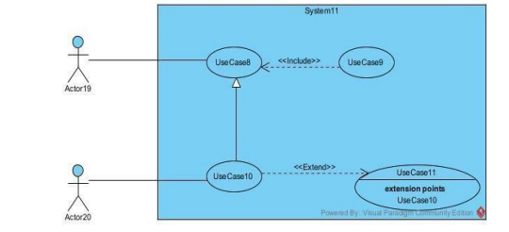
Figure 6 Use case formalism
- COMPONENTS OF USE CASE DIAGRAM

Table 9 Components of use case diagram
Elements | Notation | Notation
Actors | 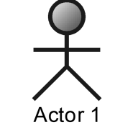 | Represents an entity that directly interacts with the system. The actor is what performs the  different possible actions of the system
Use case | 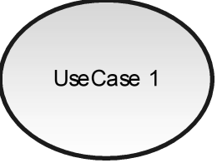 | A use case represents a functionality of the system. It is an action that can be performed by an actor.
Association | 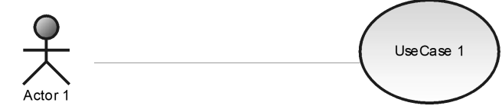 | It indicates that an actor takes part in a use  Case.
Include | 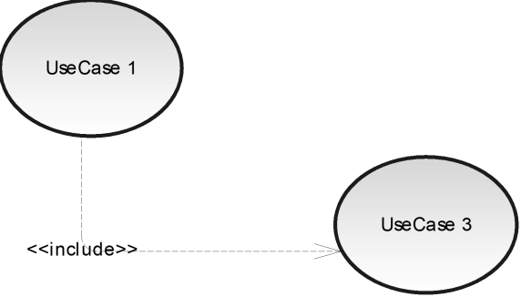 | An inclusion denotes that an included action must be  performed  before the including action can be performed.
Extend | 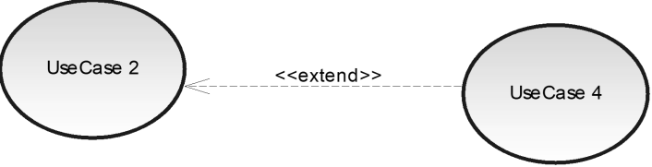 | An extension denotes that an extending action may be performed while an extended action is being performed.
Generalization | 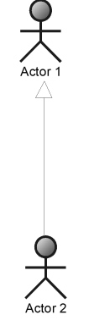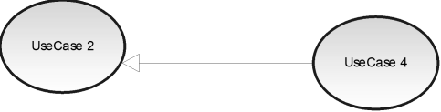 | This shows that an actor or a use case is a kind of another. Abstract or concrete actors can be defined and later specialized using generalization relationship.
System | 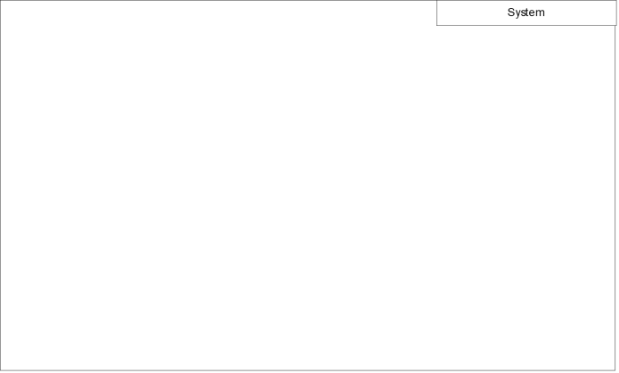 | It is a container of use cases which interact with external  actors

- THE ACTORS OF OUR SYSTEM

Table 10 Actors of our system
Actor | Role | Main Responsibilities
Student | Learner / Institution Member | Mark attendance, view official information, receive notifications, access permitted academic information, and interact with public institutional content.
Teacher | Academic Staff | Start attendance sessions, monitor student attendance, view attendance records and statistics, and identify attendance trends.
Guardian | Student Support / Family Representative | Monitor linked students, receive relevant notifications, and communicate with the institution regarding their children/wards.
School Administrator | Institution Manager | Manage institution members, roles, permissions, classes, courses, settings, and institutional operations.
School Manager | Official Content Manager | Create and publish official announcements, events, opportunities, scholarships, partnerships, institutional news, and other public information.
Explorer | Registered External User | Discover institutions, follow institutions, view public institutional information, and interact with permitted public content without being an official institution member.
Super Administrator | Platform Manager | Manage the overall Campusly platform, institutions, platform-level users, subscriptions, and global system configuration.

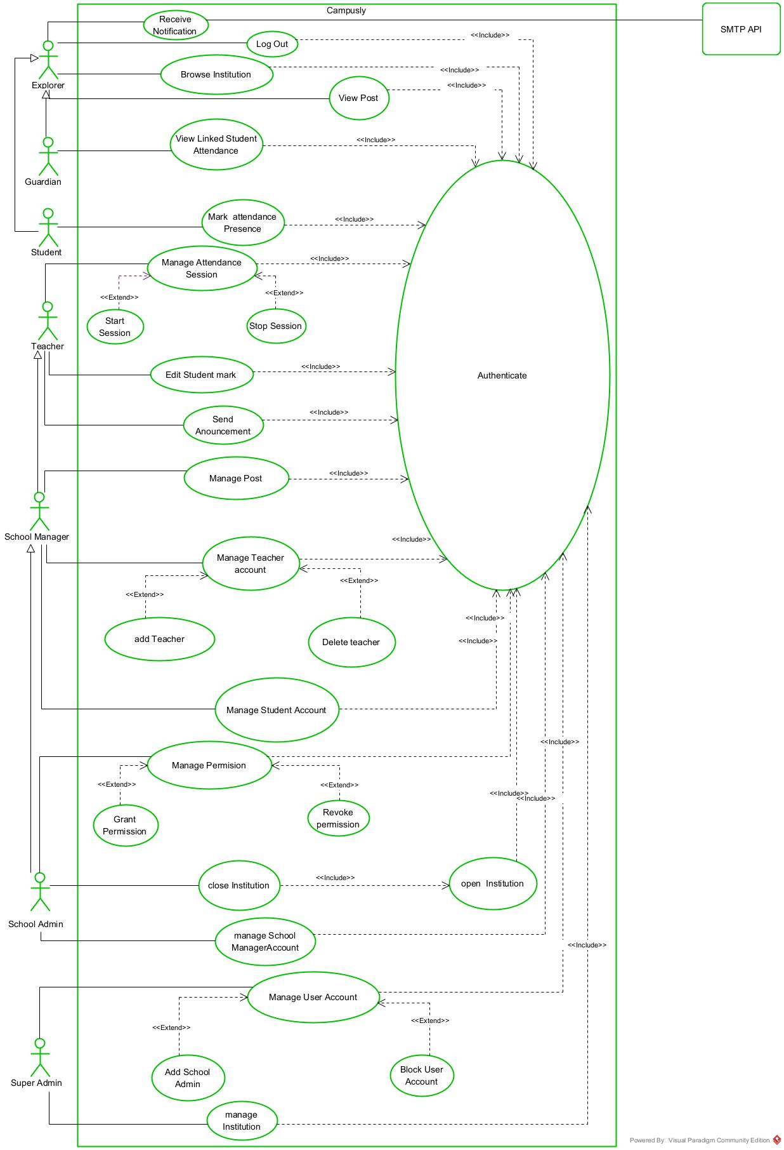
Figure 7 Campusly generale use case
- SPECIFIC USECASE DIAGRAM
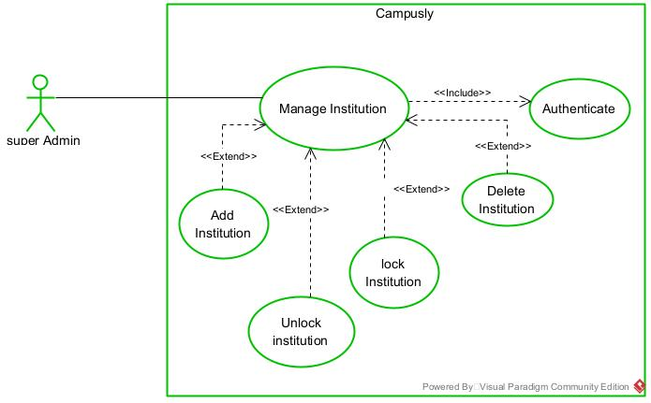
- Manage Institution
Figure 8 Specific Use case of Manage Institution

- Manage Post
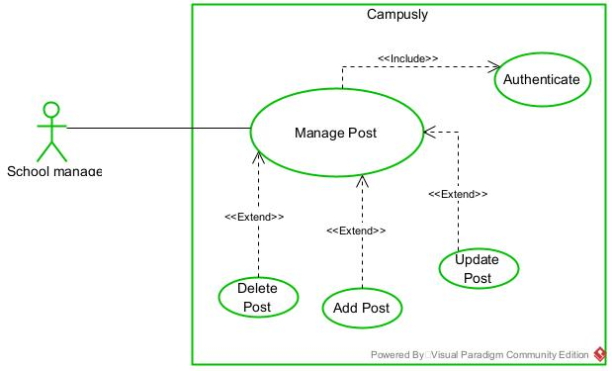
Figure 9 Manage Post

- Manage School Manager Account
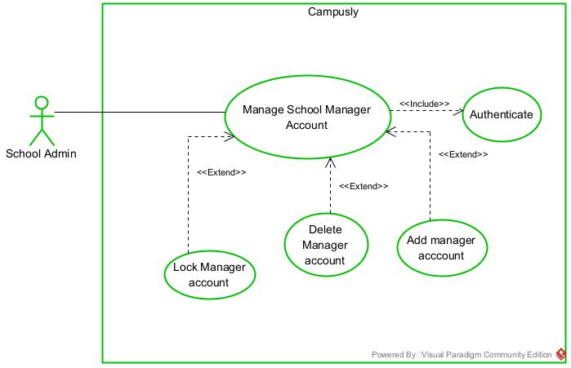
Figure 10 Manage School Manager Account

- TEXTUAL DESCRIPTION

Table 11 Authentication textual description
Element | Description
Title | Authenticate User
Summary | Allows a registered Campusly user to securely log into the platform and access the functionalities authorized for their role.
Actors | User
Date | September 10, 2026
Version | 1.0
Precondition(s) | 1. The Campusly application is available.  2. The user has a registered account.3. The user's account is activated.
Triggers | The user selects the "Login" button.
Nominal Scenario | 1. The system displays the login form.  2. The user enters their credentials.  3. The user submits the form.  4. The system validates the provided credentials.  5. The system verifies the user's account status.  6. The system retrieves the user's role and permissions.  7. The system creates an authenticated session.  8. The system redirects the user to the appropriate dashboard.
Alternative Scenarios | 4a. The user enters incorrect or missing credentials  .4b. The system displays an error message and returns to step 2 of the nominal scenario.  5a. The user's account is inactive.  5b. The system informs the user that account activation is required.
Post-condition Success | The user is authenticated, an active session is created, and the user can access the functionalities permitted by their role.
Post-condition Failure | The user is not authenticated and remains on the login page.
Non-functional Requirement | The user's password must be securely protected and must not be displayed in plain text while being entered.

Table 12 Start Attendance textual Description
Element | Description
Title | Start Attendance Session
Summary | Allows a teacher to start an attendance session for a scheduled class so that enrolled students can record their presence.
Actors | Teacher
Date | September 10, 2026
Version | 1.0
Precondition(s) | 1. The teacher is authenticated.  2. The teacher is assigned to the course/class.  3. A class session is scheduled or available for attendance.  4. The teacher's device supports the required proximity verification mechanism.
Triggers | The teacher selects the "Start Attendance" option for a class session.
Nominal Scenario | 1. The system displays the teacher's available classes/courses.2. The teacher selects the class and course.  3. The teacher selects "Start Attendance".  4. The system creates a new attendance session.  5. The system generates a time-limited attendance and security token.  6. The system activates proximity verification using Bluetooth.  7. The system displays the active attendance session to the teacher.  8. Enrolled students can now submit their attendance.
Alternative Scenarios | 4a. An attendance session is already active for the selected class.  4b. The system informs the teacher that an active session already exists.  5a. The system fails to generate the attendance credentials.  5b. The system displays an error and does not start the session.  6a. Bluetooth/proximity verification cannot be activated.  6b. The system informs the teacher that the required proximity verification is unavailable.
Post-condition Success | An attendance session is successfully created and activated, allowing eligible students to check in.
Post-condition Failure | No attendance session is created or activated, and students cannot record attendance for that session.
Non-functional Requirement | The attendance code/QR code and security token must be time-limited and securely generated. The attendance session should respond quickly to the teacher's request.

Communication Diagram
- DEFINITION
The communication diagram is used to model the specific interaction between the participants of the system. It describes both the static and dynamic behavior of the system. It shows the chronological succession of the actions performed by an actor to realize an operation.

- FORMALISM
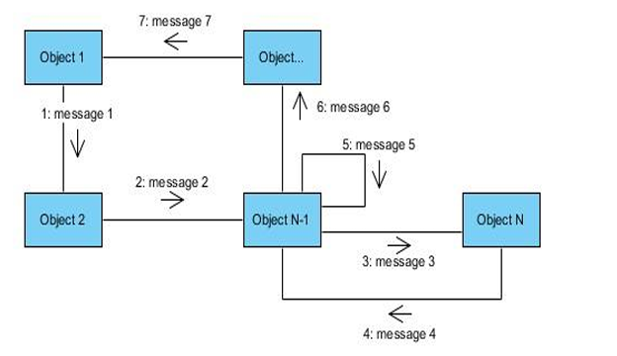
Figure 11 Formalism of communication diagram

- COMPONENTS OF COMMUNICATION DIAGRAM
Table 13 Communication diagram component
Element | Description | Representation
Object | Represents a role or object instance that participated in the interaction model. | 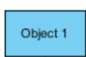
Message | Defines a particular communication between lifelines in an interaction. | 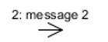
Actor | It models the type of role played by an entity that interact with the subject | 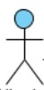
Link | It initiates an association it connects two objects together for them to communicate. | 

- Communication diagram of authenticate
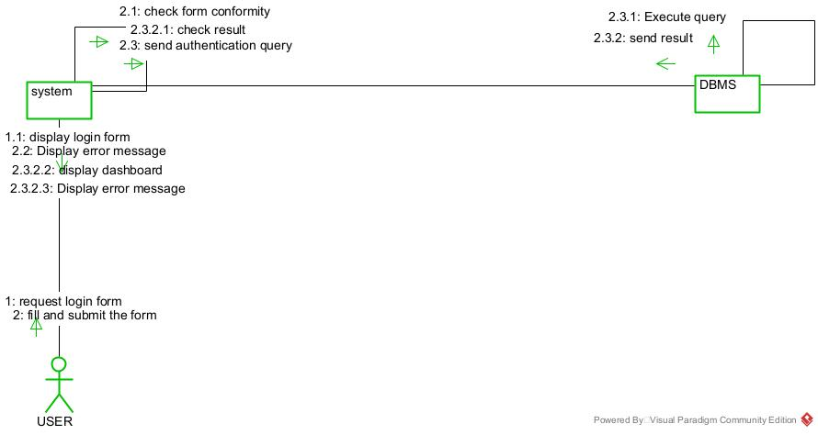
Figure 12 Communication diagram of Authenticate
- Communication diagram of Add Post
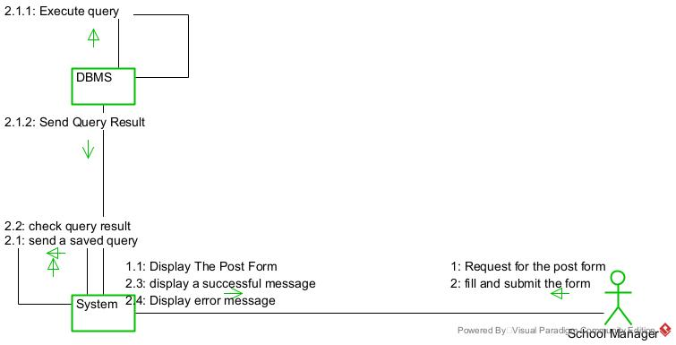
Figure 13 communication diagram of add post
- Communication diagram of Start attendance Session
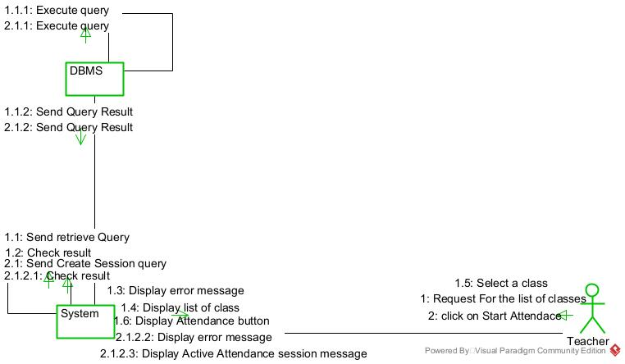
Figure 14 communication diagram of start attendance session

SEQUENCE DIAGRAM
- DEFINITION
A sequence diagram is a UML diagram that illustrates the sequence of messages between objects in an interaction. It consists of a group of objects that are presented by lifelines and the messages that they exchange over time during the interaction. These interactions are arranged from top to bottom following their order of occurrence.
- FORMALISM

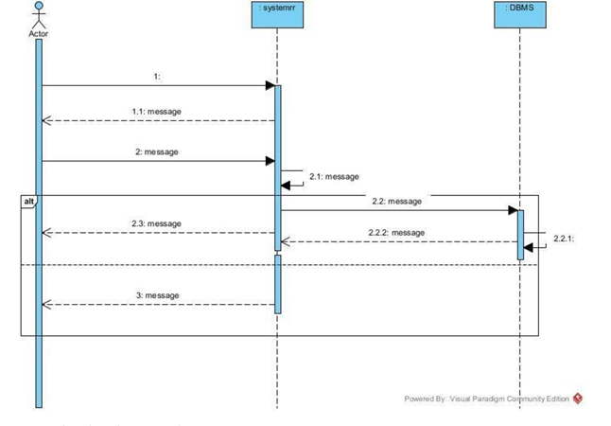
Figure 15 sequence diagram formalism

- COMPONENTS OF SEQUENCE DIAGRAM
Table 14 Component of sequence diagram
Element | Description and main properties | Representation
Lifeline | They represent rows or object instances that participates in a sequence being modeled. | 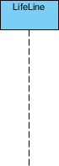
Messages | These are arrows that show the direction of message flow. We have the synchronous, the asynchronous, and the self-messages. | 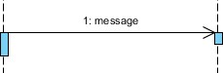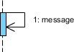
Combined Fragment | It represents a choice of behavior in which at most one operand will be chosen. | 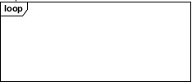
Self-Message | Represents the execution or operation call on the same object
Return Message | Represents a response to a message | 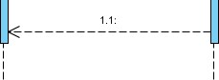
Actor | They send and receive messages.
Object | They send and receive messages

- Sequence diagram of Authenticate
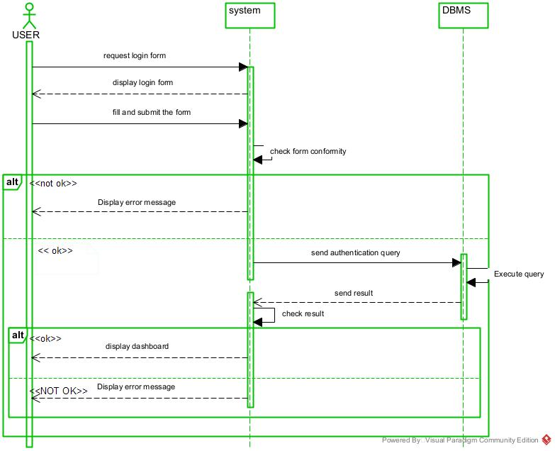
Figure 16 Sequence diagram of Authenticate

- Sequence diagram of Add post
Figure 17 sequence diagram of add post
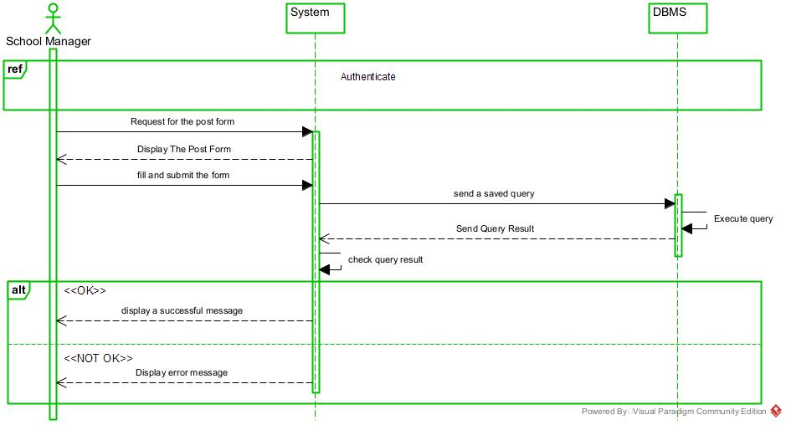
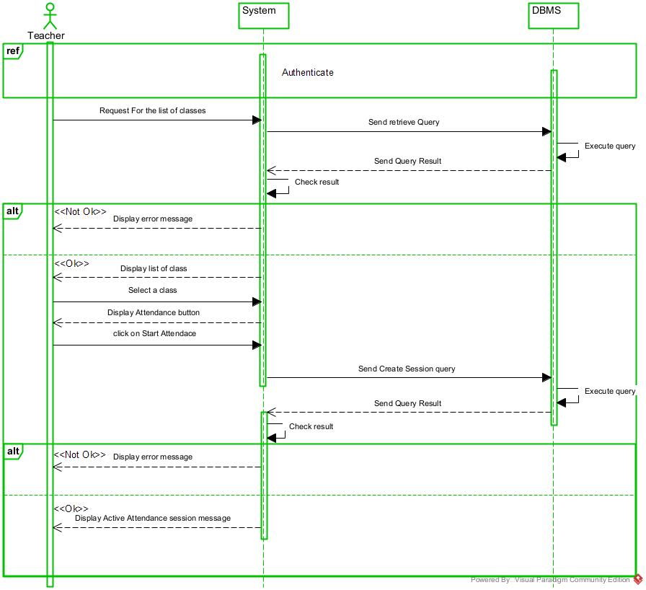
- Sequence diagram of start attendance
Figure 18 sequence diagram of start attendance

ACTIVITY DIAGRAM
- DEFINITION
An activity diagram is a graphical representation of workflows that show the steps needed in the realization of a process, showing the details from a start point to an end point through all decisions and actions that can possibly be performed. Activity diagrams are intended to model both the computational and organizational processes. The flow can be sequential, branched, or concurrent. Below is an activity diagram formalism.
- FORMALISM

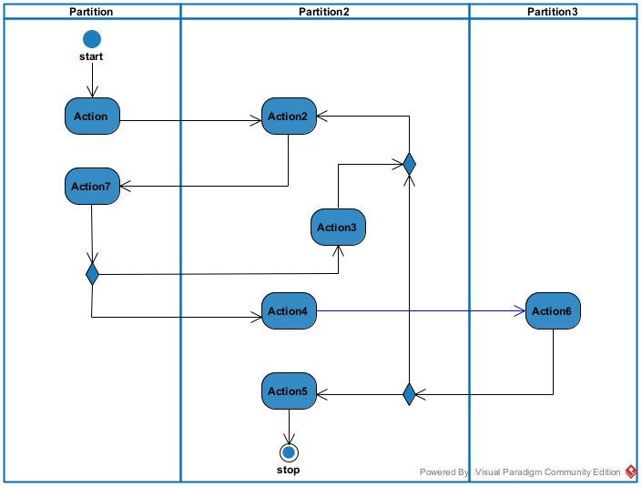
Figure 19 Activity diagram formalism

- COMPONENTS OF ACTIVITY DIAGRAM

Table 15 Components of the Activity Diagram
Elements | Description | Representation
Activity | It describes the action of an object and it is represented by rectangle with | 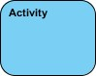
Activity edge | A directed connection between two activity nodes through which tokens may flow.
Decision node | Represent a test condition to ensure that the control flow or object flow only goes down one path | 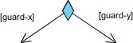
Initial Node | It is a control node at which the flow starts when an activity is invoked
Final Node | A control node that stops all flows in an activity. It is represented by a circle with a filled circle inside
Action | Represents a single step in an activity that cannot be further decomposed. | 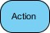
Merge node | Reunite different decision paths created using a decision node. | 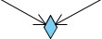
Fork node | Splits behavior into parallel or concurrent flows of activities (or actions) | 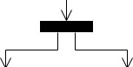
Join node | Unites a set of parallel or concurrent flows of activities or actions. | 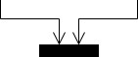
Swimlane and partition | A way of grouping activities performed by the same actor in an activity diagram or to group actions in the same thread. | Table 16 Components of activity diagram  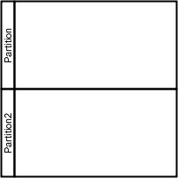

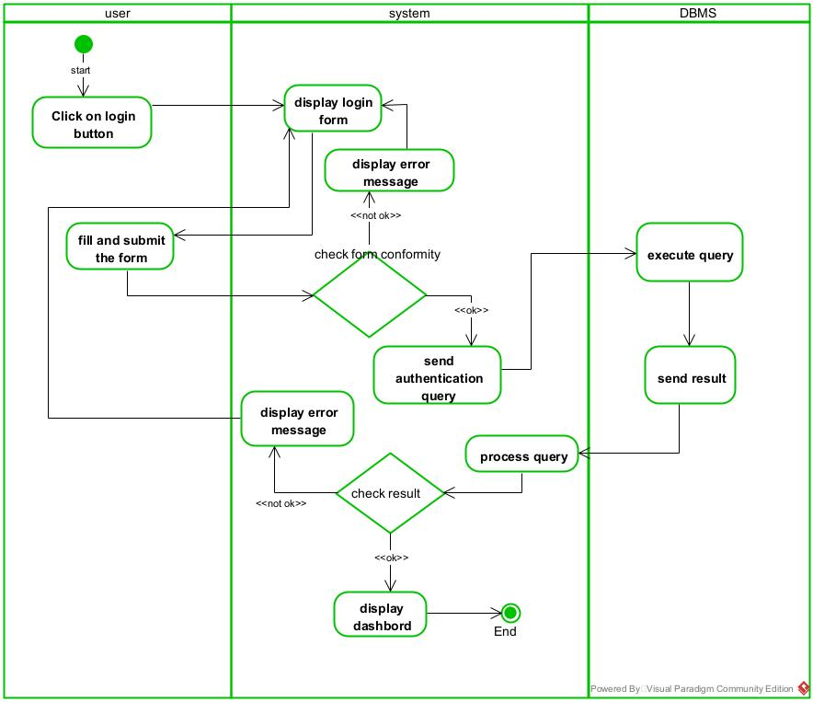
- activity diagram of authenticate
Figure 20 activity diagram of authenticate

- activity diagram of add post
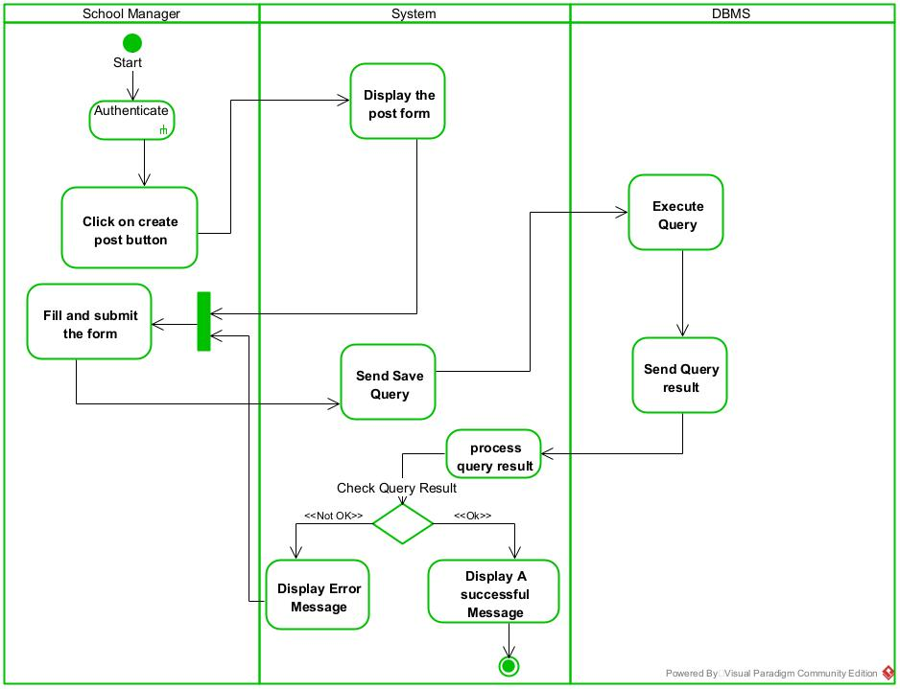
Figure 21 activity diagram of add post

- activity diagram of start attendance
Figure 22 activity diagram of start attendance
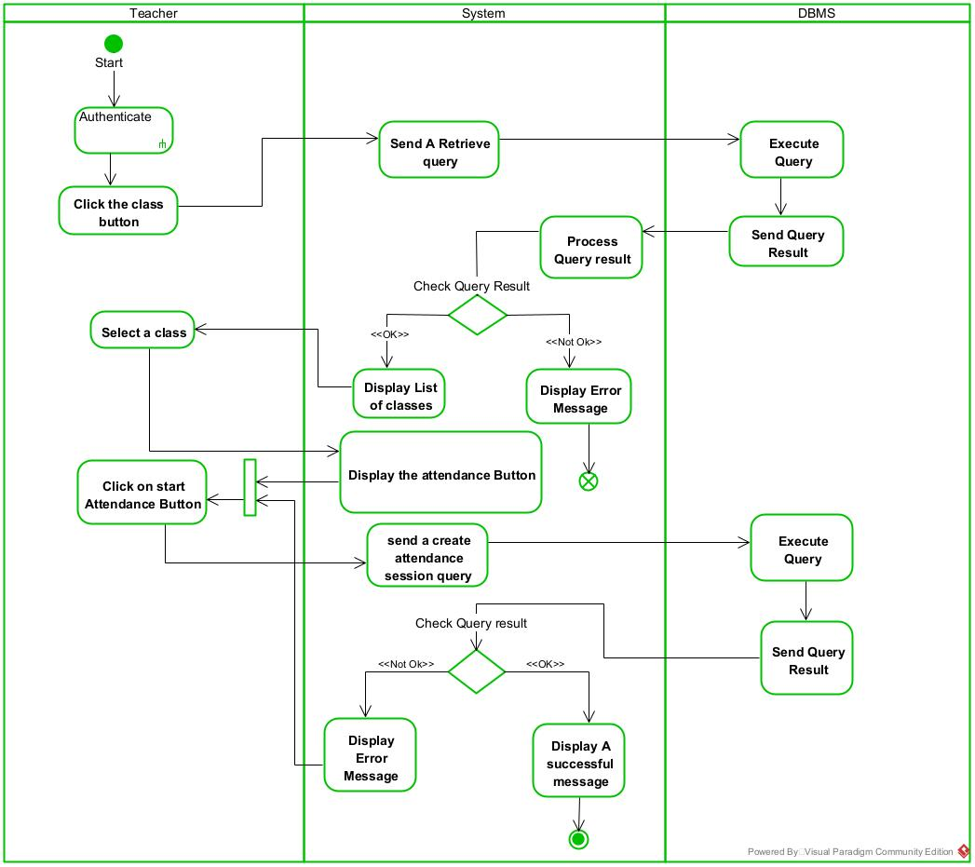

CONCLUSION
Having reached the end of our analysis, we were asked to illustrate the language and method used during this phase, present the different diagrams of the functional branch. we can then say that this analysis file has allowed us delimit the functional needs of the web application that will be designed and to have a detailed overview of the new system to be set up without notwithstanding we quickly dive into the conception phase.

PHASE 4: CONCEPTION PHASE

Preamble
This document makes it possible to model the proposed solution as a whole and to gather the information necessary to set up a complex and efficient database. It therefore foresees the future system.
Content

INTRODUCTION
- CAPTURE OF TECHNICAL NEEDS
- CLASS DIAGRAM
- STATE MACHINE DIAGRAM
- PACKAGE DIAGRAM
CONCLUSION

INTRODUCTION
The conceptual phase will describe in details the necessary specifications, features and operations that will satisfy the functioning requirements of the proposed system as modeled in the analysis phase. This phase is meant to identify and consider essential components, structure, processes and procedures for the system to accomplish it objectives. We will look at some diagrams such as the component diagram, package diagram, communication diagram, class diagram and the object diagram.

CAPTURE OF TECHNICAL NEEDS

PHYSICAL ARCHITECTURE
The design of DESIGN AND IMPLEMENTATION OF A MULTI-PLATFORM FOR ATTENDANCE VERIFICATION is based on a n-tier architecture, which effectively partitions the entire system into related but separate modules. This modular approach allows for independent modification, alteration, or replacement of each tier as needed. In our project, we utilize the n-tier architecture to separate the system components based on user interactions and the data managed within the database. Each layer has a well-defined communication interface, enabling independent evolution without impacting other layers. The n tier architecture of our system consists of the following components:
- Client Tier (Presentation Interface):
This tier provides the user interface for the mobile application, enabling organizers and contributors to interact with the platform. Organizers can create events (e.g., “Community Festival Fund”), set funding goals, and share links via social platforms like WhatsApp or Instagram. Contributors can browse events, make payments via mobile money (e.g., MTN Mobile Money, Orange Money), and view real-time contribution updates. Designed for usability, it ensures accessibility for users with minimal tech skills, even in rural areas with intermittent connectivity.
- Application Tier:
This tier consists of the web server and application server that host the hair salon booking system and hairstyle visualization app. It handles the business logic, processes user requests, and facilitates communication between the client and data tiers. This includes managing the booking process, handling user authentication, processing payments, and executing the hairstyle visualization algorithms.
- Data Tier:
This tier represents the DBMS server and file server, where all user data, appointment information, and digital assets are stored. The database server manages structured data access, retrieval, and security, ensuring that users can securely access their information. The file server handles the storage and retrieval of larger files such as hairstyle images and user uploads for visualization.

- N-Tier:
This is an extension of 3-tier.
SMTP
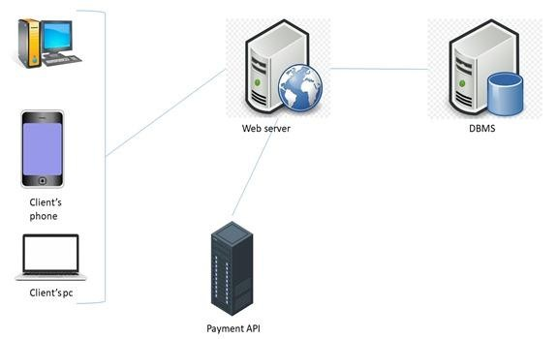
Figure 23 3-tier Architecture

LOGICAL ARCHITECTURE
Model View controller or MVC as it is popularly called, is a software design patten for developing application. A model view controller patten is made up of the following three parts.
❖ Model: The lowest level of the patten which is responsible for maintaining data.
❖ View: This is responsible for displaying all or a portion of data to the user.
❖ Controller: It handles software codes that controls the interactions between the model and the view.
MVC is popular as it isolates the application logic from the user interface and supports separation of concerns. Here the controller receives all requests for the application then works with the model to prepare data needed by the view. The view then uses the data prepared by the controller to produce a final response. The MVC can be represented as follows:

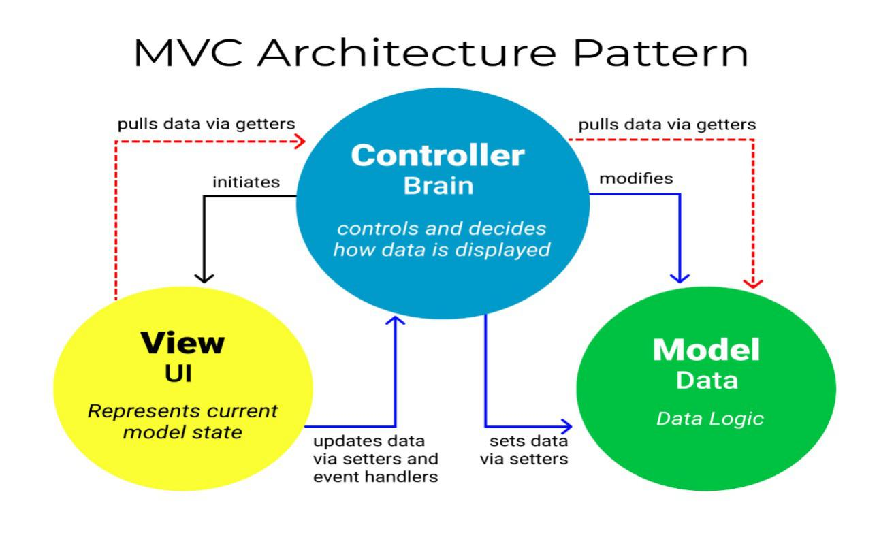
Figure 24 Logical Architecture

CLASS DIAGRAM
- DEFINITION
A class diagram is a static diagram. It represents the static view of an application. class diagram is not only used for visualizing, describing, and documenting different aspects of the system, but also for constructing executable code of the software application. A class diagram describes the attributes and operations of a class and constraints imposed on the system. Its purpose is to model the static view of an application.
- FORMALISM

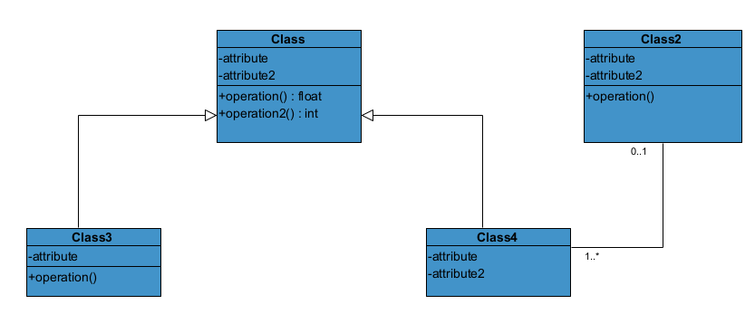
Figure 25 Class Diagram formalism

- COMPONENTS OF CLASS DIAGRAM
Table 17 Components of a class diagram
Elements | Description | Representation
Class | A class is an element that defines the attributes and behaviors that an object can generate. | 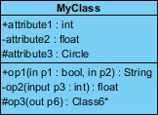
Composition | If a parent of a composite is deleted, usually, all its parts are deleted with it. | 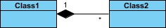
Aggregation | If the parent of the aggregate is deleted, usually the children are not deleted. | 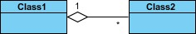
Dependency | It existed between two classes; if one changes it may cause a change in the order, but not the other way around. | 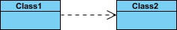
Generalization | It is a relationship between a whole thing (called a superclass) and a more specific thing (called a subclass) | 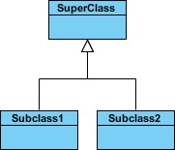
Association | It is a general type of relationship between elements; it may include cardinality, roles, etc. | 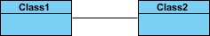

- CLASS DIAGRAM
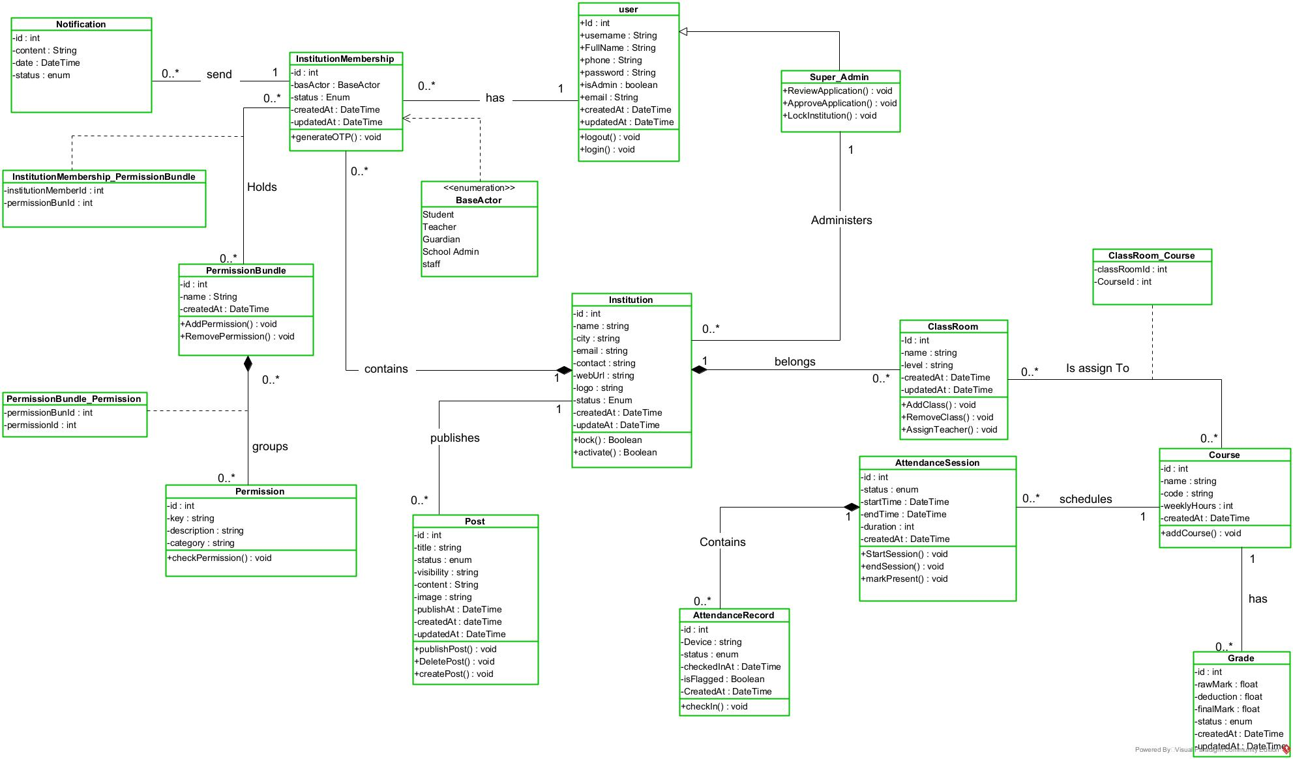
Figure 26 Campusly Class Diagram

STATE MACHINE DIAGRAM
- DEFINITION
A class diagram is a static diagram. It represents the static view of an application. Class diagrams are not only used for visualizing, describing, and documenting different aspect of the system, but also for constructing executable code of the software application. A class diagram describes the attribute and operation of a class and constraints imposed on the system. Its purpose is to model the static view of an application.
- FORMALISM
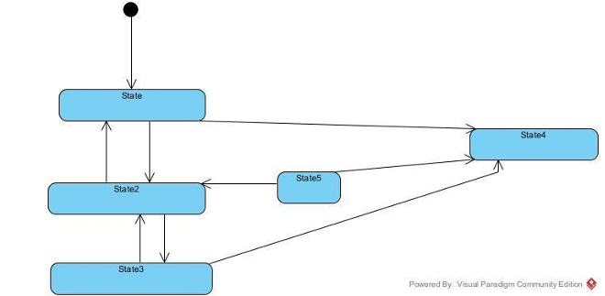
Figure 27 Formalism of state machine diagram

- COMPONENTS OF STATE MACHINE DIAGRAM
Table 18 components of state machine
Elements | Description | Representation
Final state | A state specifying that the enclosing region is  complete
First (Initial State) | It represents a default vertex, that is, a source for a single transaction to the default or composite state.
State | Models a situation in which a certain invariant condition holds. | 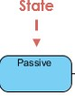
Transition | A direction relation between a source and a target vertex. | 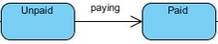
Choice pseudo state | A diamond symbol that indicates a dynamic condition with branched  potential results
Terminate | Implies that the execution of a state by means of its context is terminated.

- STATE MACHINE DIAGRAM
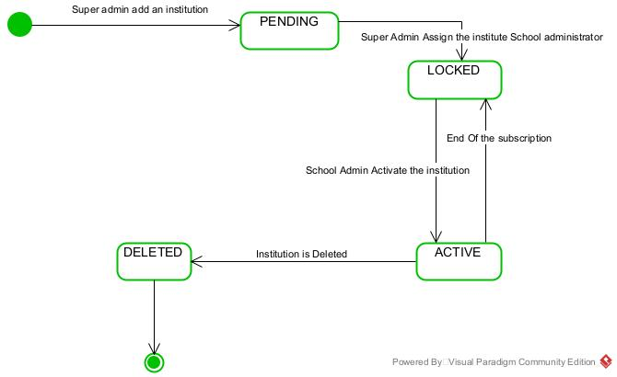
- State machine of institution
Figure 28 state machine of institution

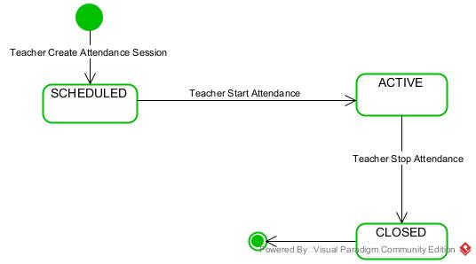
- State machine diagram of attendance
Figure 29 state machine of attendance

PACKAGE DIAGRAM
- DEFINITION
They are structural diagrams used to show the organization and arrangement of various model elements in the form of a package. A package diagram is a group of related UML elements such as diagrams, documents, classes, or even other packages. Package diagrams are commonly used to provide a visual organization of the architectural layout within any UML classifier, such as software systems.

- FORMALISM
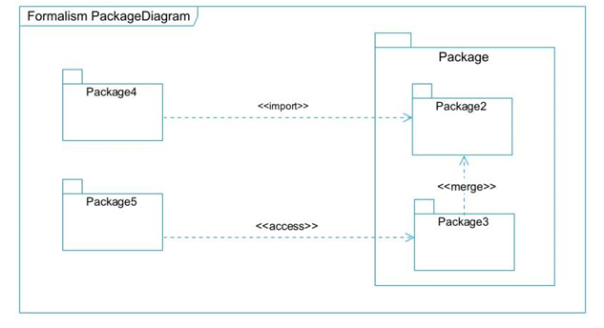
Figure 30 Formalism of package diagram

- COMPONENTS OF PACKAGE DIAGRAM
Table 19 Components of a package diagram
Elements | Description | Representation
Package | It is a namespace used to group together logically related elements within a system. Each element within the package should be a packageable element and have a unique name. | 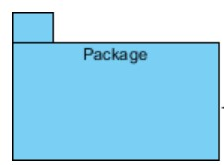
Package import | A relationship indicates that functionality has been imported from one package to another. | 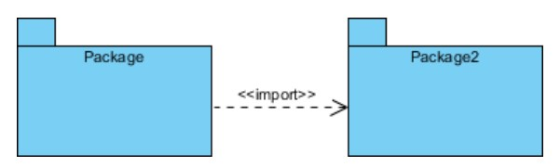
Package access | A relationship indicates that one package requires assistance from the function of another package. | 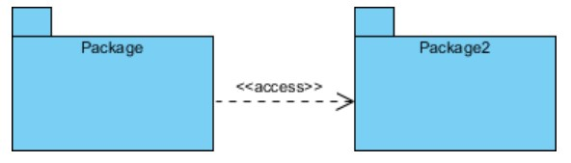
Package merge | It is a relationship which shows that the functionality of two packages is combined into a single function. | 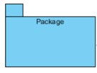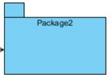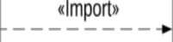

- PACKAGE DIAGRAM
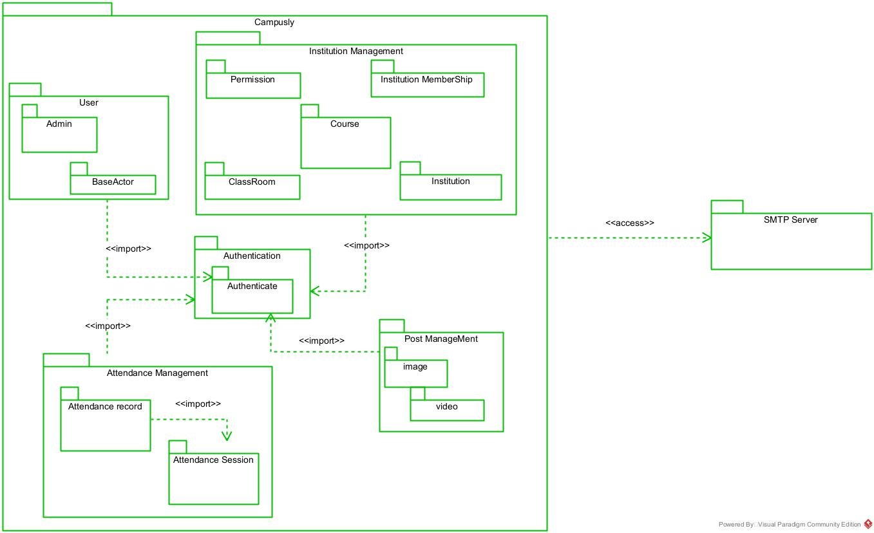
Figure 31 Package diagram

CONCLUSION
The conception phase allowed us to bring out the data necessary for the creation of our database and the implementation of our application. The different elements modeled in this part allowed us to have a global view of the different modules of our application; therefore, the next step of our project will be the drafting of the realization file, taking into account the different elements modeled above.

PHASE 5: REALIZATION

Preamble
The realization document consists of the implementation of the project in a programming language according to the specifications defined in the previous file. It contains component and deployment diagrams, the testing and development phases. At the end of this part, programming documentation will be produced explaining the architecture of the database and the architecture of our code.
Content

INTRODUCTION
- DEPLOYEMENT DIAGRAM
- COMPONENT DIAGRAM
- TECHNICAL CHOICES
CONCLUSION

INTRODUCTION
Here in the realization phase, we will concentrate on building or implementing our solution, based on the different analysis and conception that we had carried out, which will help to facilitate our work, this phase is as critical as the previous phases. We are going to look at the relationship that exist between the entities of the entity relational diagram. Furthermore, we will see the choices of technologies used for the implementation of our system.

DEPLOYMENT DIAGRAM
- DEFINITION
The deployment diagram models the hardware components used to implement a system and the association between those components. Deployment diagrams can be implemented as early as the design phase to document the system's physical architecture. As elements used in deployment diagrams, we can have, components, as in component diagrams, and nodes, which represent the physical processing resources of the system, and their associations.
- FORMALISM
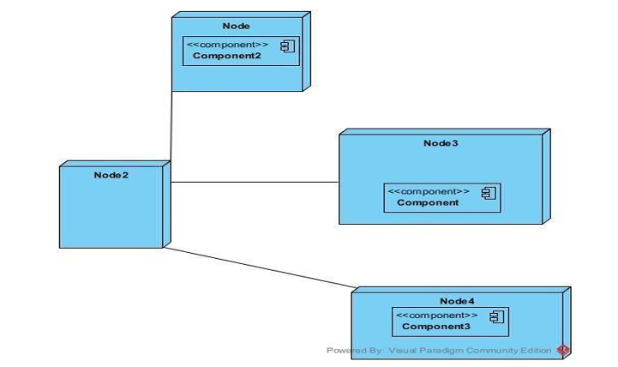
Figure 32 Formalism Deployment diagram

- COMPONENTS OF DEPLOYMENT DIAGRAM

Table 20 Component of the deployment diagram
Elements | Description | Representation
Component | A component represents a software entity of the system. | 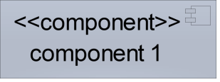
Node | A node represents a set of hardware elements of the system. A three-dimensional cube represents this entity or node. | 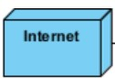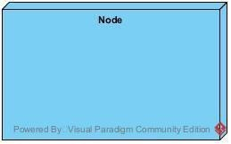
Interface | Represents a declaration of a set of coherent public features and obligations | 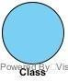
Dependency (manifestation deployment) | A relationship between two model elements where changes in one of them will similarly affect the other | 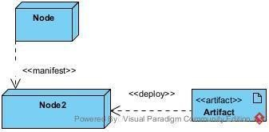
Artifact | An artifact is a major product, that is produced or used during the development of software. E.g, diagrams, data models, setup  Scripts. | 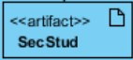
- DEPLOYMENT DIAGRAM OF
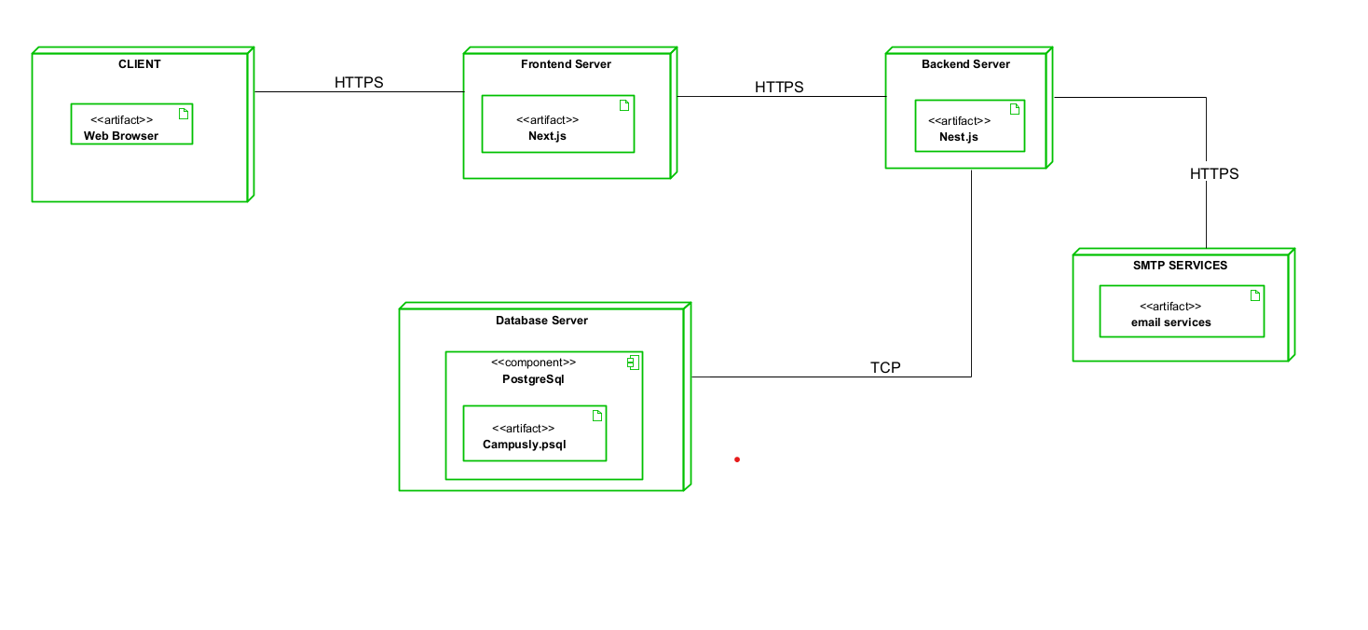
Figure 33 Deployment Diagram

COMPONENT DIAGRAM
- DEFINITION
Component diagrams are used to model the physical aspect of a system. Now the question is, what is this physical aspect? They are elements such as Executables, libraries, files, documents, etc., which reside in a node. The component diagram does not describe the functionality of the system, but it describes the components used to make those functionalities.
- FORMALISM
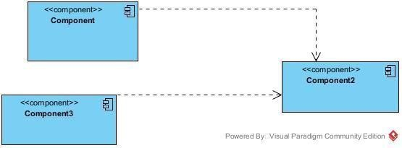
Figure 34 Formalism of Component diagram

- COMPONENTS OF COMPONENT DIAGRAM

Table 21 Components of component diagram
Element | Description and main featur |  | Representation
Component | Represents the modular part the system that encapsulates content. In other words, it is part of a system or application |  | 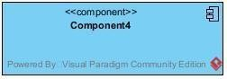
Interface | Represents a declaration of  a set of coherent  public feature  and obligations |  | 
Port | Specifies a distinct  interaction point  between that  classifier element  and environment |  | 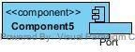
Usage | A relationship in which one element requires another element for its full  implementation or operation | 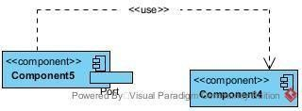
Instance Specification | It has the capability of being a deployment target in a deployment relationship | 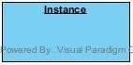

COMPONENT DIAGRAM OF CAMPUSLY
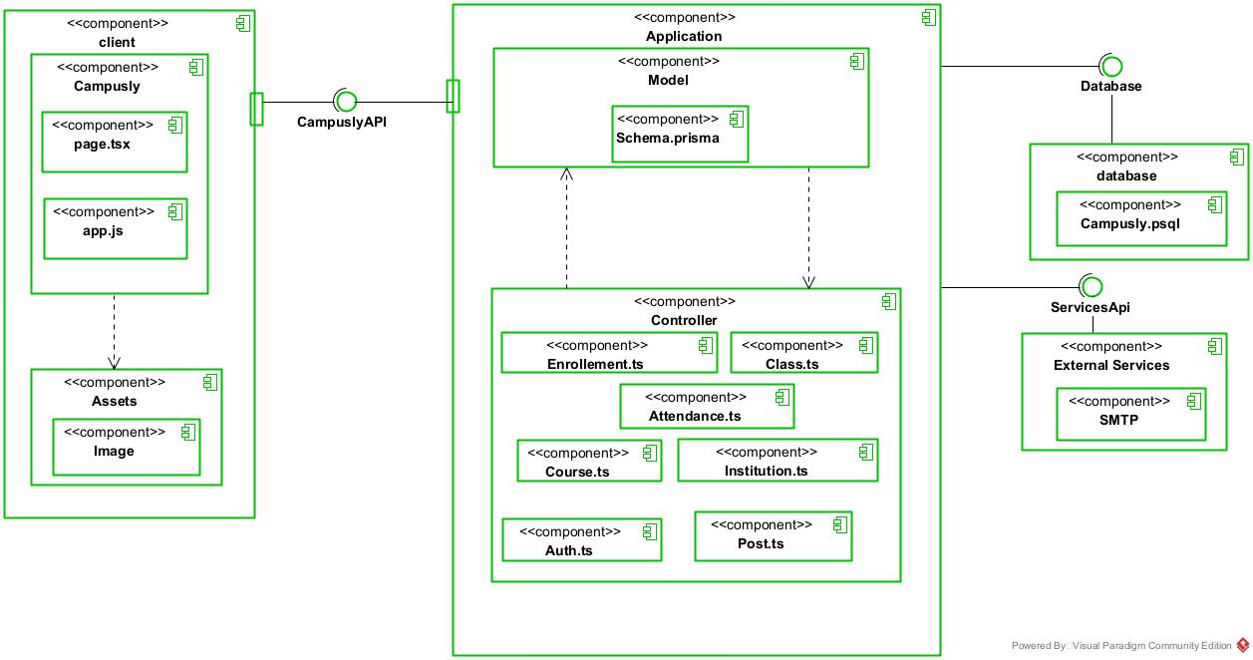
Figure 35 Component Diagram

TECHNICAL CHOICES
Table 22 Technical choices
Software | Role | Image
OS  WINDOWS  10 | The operating system required to run the software is the one on which we have worked. | 
Visual Paradigm | The software engineering workshop used for solution modelling. We utilized this tool for modelling the various diagrams of our system | 
Visual studio code | Visual Studio Code is a lightweight, open-source code editor developed by Microsoft, supporting multiple programming languages. Using for writing of application code. | 
Github | It is a website and cloud service that helps developers store and manage their code. | 
Framework  react | A popular React Frame work for building our frontend | 
NESTJS | NESTJS is a popular java script frame work for building backend | 
PostgreSQL | PostgreSQL is a popular open-source relational database management system | 
MS Word | MS Word is a widely used word processing application that allows users to create, edit, and format text documents. Using in application report creation. | 
MS Power Point | MS PowerPoint is a presentation software that allows users to create dynamic slideshows comprising text, images, videos, and animations. Able us to create slideshows presentations for application. | 
Chrome | Google Chrome is a fast, secure, and user-friendly web browser developed by Google. Used to test our application UI | 
GanttProject | GanttProject is a free, open-source project management tool that allows users to create Gantt charts for planning and scheduling projects | 

CONCLUSION
During our realization phase, we successfully developed and implemented our application. To achieve this, we utilized our analysis and conception phase. We also created deployment and component diagrams which illustrate the modules, files, and assets, as well as how different elements interact with each other within our system. Our next step is to move onto the functionalities testing phase, where we will assess the efficacy of the various modules present in our app for different users.

PHASE 6: FUNCTIONALITY TESTING

Preamble
This phase aims at testing the software or application to verify if the system is working as expected. It involves testing individual functionalities and capabilities of the software to ensure that they work correctly and meet the specified needs.
Content

INTRODUCTION
- APPLICATION MODULES
- TESTING
CONCLUSION

INTRODUNCTION
It is a systematic process that involves evaluating the functionality of a software application or system in different phases or stages of its development lifecycle. This testing approach ensures that each phase of the software development process is thoroughly tested for its intended functionalities and overall performance. Its main goal is to identify and rectify any defects, and bugs during the process.

APPLICATION MODULES

TESTING
DEFINITION
Testing, in simple terms, involves verifying that your code functions correctly. It is important because it boosts your confidence in the code and ensures its reliability. There are different types of testing, including:
- Unit test: In a unit test, you are testing whether each function is working properly.
- Feature test: In a feature test, you are testing whether your routes, controllers, and database behave as expected.
- Manual testing: Here, you are manually testing your application.
- Alternative or Automated testing: Using tools online to test your code.

TESTS MADE IN THE SCOPE OF OUR PROJECT

CONCLUSION
Testing is an integral part of the software development life cycle and is performed to verify the correctness, reliability, and robustness of the implemented functionality. The functionality and testing phase is therefore a critical stage in software development where the implemented features are validated, and any issues are identified and resolved

PHASE 7 USER GUIDE

Preamble
A user guide explains how to use a software application in a language that a non- a technical person can understand. Thus, it enables the user to easily use the application to familiarize themselves with the software and discover all its functionalities.
Content

INTRODUCTION
- DESCRIPTION OF THE APPLICATION
- USER MANUAL
CONCLUSION

INTRODUCTION
The user manual is the document established after the realization of an application, software or platform. It informs on the question "how to use the software, the application or the platform that you have in front of you? ". It is therefore crucial for us to offer the various users of our platform a guide allowing them to easily perform various operations on our platform.

DESCRIPTION OF THE APPLICATION

USER MANUAL

PREREQUISITES

USEFUL STEPS
Below are the steps you will have to follow to get it running on your machine:

SHOW CASE

CONCLUSION
This user guide has provided a comprehensive overview of our product's features, functionalities, and best practices for optimal use. By following the instructions and tips outlined in this document, you'll be well-equipped to maximize the potential of our product and streamline your workflow.

GENERAL CONCLUSION

ANNEXES

BIBLIOGRAPHY

WEBOGRAPHY

TABLE OF CONTENT

